Tear Gas & Shotgun Injuries: Bahraini Authorities’ New Year in Sitra
http://bahrainalyoum.uk/?p=44025

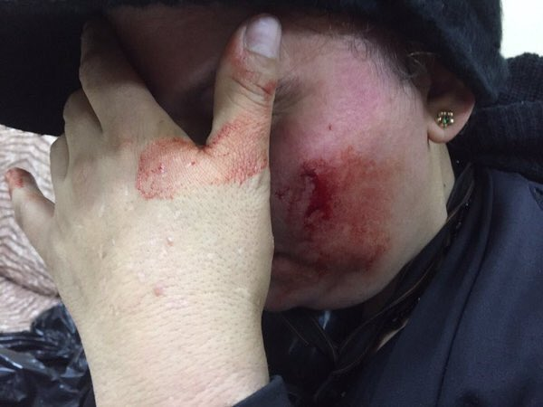

On 1 January 2016, security forces suppressed protests in Sitra with extensive use of tear gas and shotgun pellets.
Pictures published on social media websites showed shotgun pellets’ traces on walls and residents’ cars. Moreover, several injuries were documented among protesters, some of them women.
Activists said that authorities’ “brutality” in suppressing protests is part of their “systematic escalation” in response to citizens’ determination to continue with their revolution into the new year. A large number of protesters attended these demonstrations, despite the authorities’ crackdown and suppression.
According to opposition activists, the government wanted to demonstrate that it would implement the same “suppression which it implemented the past year.” They pointed out that the intensity of suppression in Sitra today shows the government’s failure to stop a movement that will always be renewed among Bahrainis.

