**Arrest of Sheikh Abdulzahraa al-Mubasher**

<http://bahrainalyoum.uk/?p=38701>

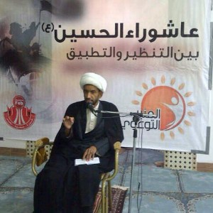

On 20 October 2015, security forces arrested Sheikh Abdulzahraa al-Mubasher after he was summoned for interrogation.

Activists said that there has been no news about Sheikh Abdulzahraa since he went to the Criminal Investigation Directorate which is known as a torture center.

Sheikh Abdulzahraa has participated in delivering a series of religious lectures during the Islamic month of Muharram and as part of the activities in Nuwaidrat.

Young men have called for protests and sit-ins during the timing of Sheikh Abduzahraa’s lectures in protest to his arbitrary arrest.

Sheikh Abdulzahraa is known of his speeches and participation in pro-democracy protests.