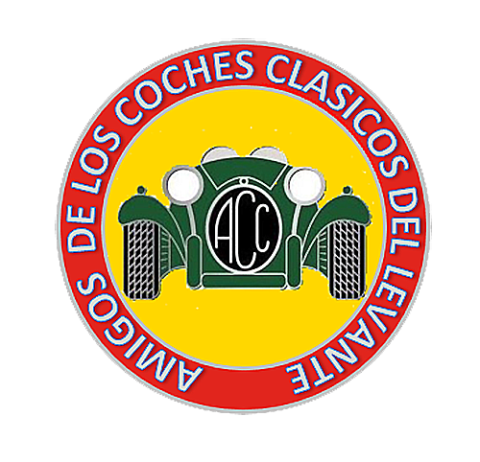
AMIGOS DE LOS COCHES CLASICOS DEL LEVANTE

Web: www.a-c-c.es e-mail: info@a-c-c.es Nº de Reg. 4141

MINUTES OF CLUB MEETING

Date: 4th April 2023 Venue: Atalaya Brassa Huercal Overa Meeting start time: 3.15pm
Officers: , Alan Foreman, Will Gater, Ken Oliver (Minute taker) & Steve Hales (Dep.Chair convened meeting)..
- Welcome :- Steve welcomed everyone 27 members attended. (Plus 2 who remained outside)..
- Apologies:- David & Sue Fox, Chas Judy Longhurst, Mark Wendy Garrity..John Bailey, Jane Horst,
- Barry & Brenda Dennis, Kevin Jones, Julian Hockridge, Peter Dutton, Lel Garfitt, Roger Vekemans,
Minutes of the last Meeting put to the floor:- Proposed acceptance, Will Gater : Seconded, Alan Foreman.
- Matters Arising:- None.
- Reports
a) Treasurer: Ken Oliver:- submitted a club balance of 1096.00 euros. Ken anticipated this would increase slightly during this meeting due to outstanding fees and the Heads & Tails fun game, proposed at the club gathering at Atalaya Brasso three weeks ago. Alan will take control of membership updates etc. He later handed over 50 euros from two annual fee renewals.
b) Membership: Alan Foreman:- welcomed upon their return Sarah and Colin Riach. Alan will continue to chase up members who have not renewed their membership as yet Outstanding fees are due by the end of April then existing member will be removed from the membersip list and renew membership if required.
- Regalia: Carol and Bob Pemberton. Carol reported that due liason was required from Alan F regarding new members welcome packs (shirts etc).. Alan F to update members list and communicate to Carol.in order new members receive relevant packs in due time.
Bob is looking into obtaining club business cards/flyers for members to distribute at events attended. Bob continued to inform members that the quality of the prinitng relative to club shirts is not at an acceptable level. The original print company has ceased operations and Bob will be contacting a new supplier in Arboleas.
Sean M requested a shirt for his soon to be wife Karen. Carol requested Sean to contact him outside meeting for sizes. (This was discussed at the drinks table post meeting).
d) Events: Steve Hales: Steve gave an update on club outingss, a full list has been posted on the club website. He specified Oct and Nov are still vacant and embers are requested to accomodate these two outstanding months
David & Sue/May, Chas & Judy/June, Alan & Brenda/July, August there is a concentration in Velez Blanco in the evening details nearer the time but is usually the begining of the month, September is Malcom & Jean 3 days away, more rooms available – contact Malcolm directly.. October & November/vacant , Ken & Jacquelyne/Christmas run/lunch..
As an aide memoir a full list of previous run outs can be obtained by refering to the club website...
No run in March, but members did meet at Atalaya Brassa for an additional informal gathering.,
Alan & Margaret F have organised a run out on the 20th April. Meeting at Atalaya Brasso (agreed post meeting) followed by a run and lunch stop at Eugenios’ where the food has been highly recommended. 13 euros per head 4 coursed with coffee included. Timings and further details to follow.
Steve reminded all members of the upcoming Retro show @ Roquetas de Mar 14-16th April 11 euros per couple, which looks to be an enjoable event. Steve has sent a link for those proposing to attend via our wattsapp group.
e)Website Administrator: Will Gater: Will continues his splendid work in keeping the club website updated and requests members to use it or we may lose it. Will stated that members should be wary as to adding external links to our Wattsapp group, this could cause damage from unwanted cookies etc... Thanks again Will.
Will sent out the newsletter on Ken's behalf.on the 4th April.
f) Magazine/Media: Ken once again asked for any news or anything to put in the newsletter. Alan F and Peter U stated they had progress reports on their vehicles to post in the near future.
No members had submitted answers to this months quiz in the newsletter. won the quiz this month.

Members Draw – Ken O requested Sarah R to draw a number from the bag. Number 31 was drawn which resulted in Dickie Bird winning the amazing sum of 30 euros. Congrats Dickie !!!!
(No more club draws, Heads and Tails to replace with a guaranteed winner each month)
AOB – Ken tempted all attendees to dig deep for 1 euro each to enter the Heads and Tails fun game. The prizes were chocolates or a bottle of really really expensive Vino Tinto. It was tense resulting in Peter U and Alan F the last two remaining atnding. Te result was that Alan won and decided to take the wine after due consultation with Margaret.
Ken gave a brief update on the trials and tribulations of matriculating has DB7 Aston Martin Cabrio. He remains optimistic come June ’23, having then owned the vehicle for a period of 6 months..
Will takes over GDPR from Karen/Ken (Post meeting)
Brief discussions took place regarding matriculation onto ‘H’ pated vehicles. It was noted that vehicles must be 30 years or older to be ‘H’ plated..

Meeting Closed @ 3:55 pm Next meeting 4th May 2023.

