The ESTEC Golf Club

  - Free golf clinics
Tuesday 26 & Thursday 28 March
17.45-18.30 on the ESTEC Golf Course
All equipment provided
Places are limited so please register: info@egcgolf.nl
www.egcgolf.nl
Our Golf Club welcomes everyone
It doesn’t matter if you are a beginner or an experienced golfer,
if you are 9 or 99,
or if you’re an ESTEC employee or family member
We believe golf is a game for everyone

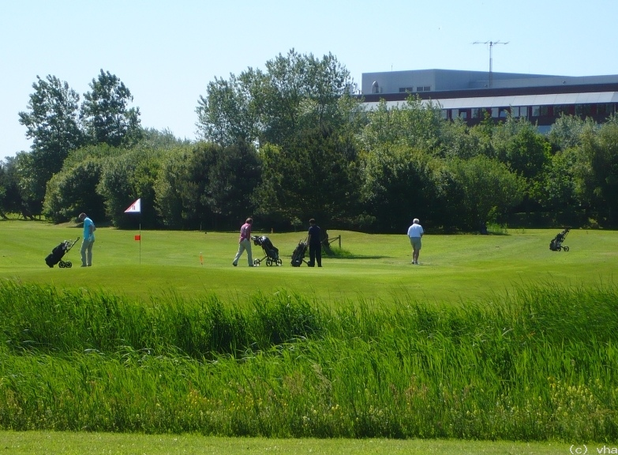
Our Golf Club offers
- A professionally maintained 9-hole course
- On-course lessons from a Pro for individuals and groups
- Competitions for all levels in a friendly atmosphere
- Registration with the Dutch Golf Association (NGF)

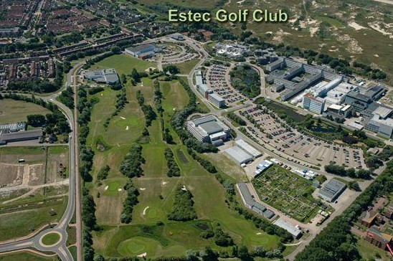
Our Golf Club – the cheapest in the country!!
All this only 5 minutes from your desk.
In the middle of nature, you can enjoy a round of golf with friends, family or colleagues.

www.egcgolf.nl

