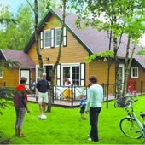 RESERVATION FORM MOLENHEIDE

Name off the delegation : …………………………………………………….

Contact name : ………………………………………………………….

Address : …………………………………………………………………………….

Email : …………………………………………………. Tel. : ………………………………………

Arrival date : ……..…… Departure date : …….……… Number of days : ……

Bungalow type : Relaxis : … Oasis : … Mundo : … Agora : … Patio : … Patio+ : …

Method :
- Receipt of this application form for a stay in Molenheide by email: iyc-hasselt@hotmail.com .
- We will contact Molenheide for a reservation.
- After receiving Molenheide's approval, we will send you the confirmation along with the payment overview, and you must then transfer the costs of your stay in Molenheide to us as scheduled.
- If the requested cottages are not available, we will help you looking for an alternative.

