- Ratified new Committee Members:
  - Pema Lhamo: International Rep
  - Sophie Shang: Academic Officer #3
- Room booking request:
  - Request: “May I ask if I can book the MCR on 20 July 2024 from 10 am – 6 pm, please? I’d like to use the room for getting ready and family gatherings before the evening reception. There will be at most 30 people in the gathering.”
  - Constitution: “The MCR Common Room(s) may be booked at a set charge decided by the MCR Committee. Each member may book a room only once a term and he/ she is responsible for informing the President well in advance so that members may be notified that the room will be occupied. The member is responsible for any damage caused by him/herself or his/her guests and for cleaning and tidying up the room afterwards. Bookings may not be taken on “Guest Nights”. The MCR Committee may refuse a booking.”
  - Questions to ask before a decision can be made:
    - Are we allowed to have a group booking of the MCR? Katja will ask John Banbrook about this.
    - Are they affiliated with the MCR?
    - What logistics do they have in mind (do they set up and clean themselves; is the usage limited to the MCR or other parts of EPH like the kitchen)?
    - What is our set charge? What is the deposit? In the past, the room has been rented out for GBP 40 per hour but we would at least ask for 50.
- Survey outcomes - Outreach with part-time students:
  - They asked for a part-time student committee post. We decided that we are going to poll part-time students first to see whether this is needed since we want to avoid increasing the number of committee posts but if there is a need for this we want to make it happen.
  - They proposed for us to survey part-time student needs as an exclusive exercise. We want to do this and Peter will organise it. Further, he will create a group chat for part-time students so they can network. For this, it might be helpful to get a list of the current part-time students from college or at least the number.
  - They also asked for a better inclusion of the interest/needs of part-time Stanners living outside Oxford. We want to do that and get an idea of said need via a survey. Further, there is funding of activities planned by any Stanner so if they have concrete ideas that they want to implement, they or we can do this.
- Community Week - Updates Peter:
Peter met Stacey from the dev office and Dev, the JCR, and the MCR have a lot of activities planned but further ideas and comments are always welcome by Peter.
- Ideas Contest Outcomes:

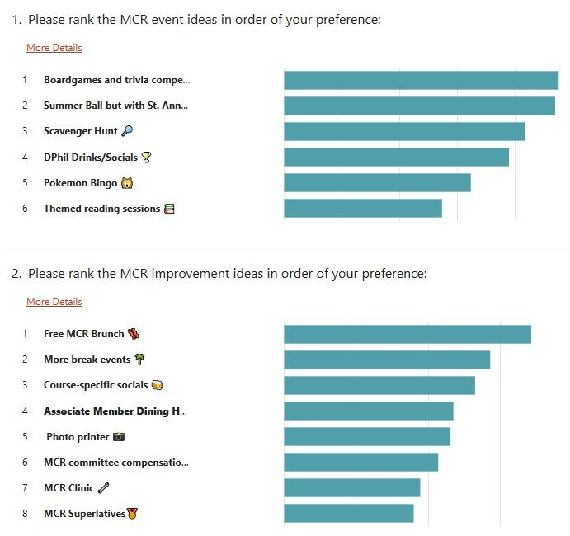
We want to implement as many of these as possible but at least the winning ideas.
- Bank Mandate:
Yayun explained the situation with the MCR bank mandate and read aloud a proposal that she, John Ford, and Jacqueline Kuspisz will be on the mandate and that after each election the new treasurer gets on the mandate while John and Jackie stay on it permanently. We were informed that we can deny this proposal but we approve of John Ford, and Jacqueline Kuspisz being on the mandate permanently.
- Budget:
There was a misunderstanding in previous committees and ours that the income for charities and Refugee levies is for the MCR to spend. This is not the case so the budget needs to be revised with the lower income and we need to build reserves to eventually pay the money to charities of our choosing and the levies to the university. To revise the budget, we will have a dedicated meeting in week 4 HT at the latest.
Further, the college raised the price for UCR dinners which currently the MCR is covering but we cannot subsidise the dinners. Hence, the price needs to be raised to GBP 30 effective immediately.
- Committee compensation:
We need to brainstorm until the next meeting:
  - How happy are we with the current system?
  - What would we like to see as a future compensation
    - From College
    - Internal: Formal dinner paid from MCR money?
- How to increase MCR engagement:
  - Problem: Less engagement in MCR and committee since COVID-19, same for SCR, not for JCR.
  - Info: The college is now (!) more alert because Katja mentioned it in a lot of college meetings. They are more than open to hearing our suggestions and help!
  - Fix: ??? We think that grad housing close (!) to college or even better in college might be a gamechanger but will continue to think about this too.

