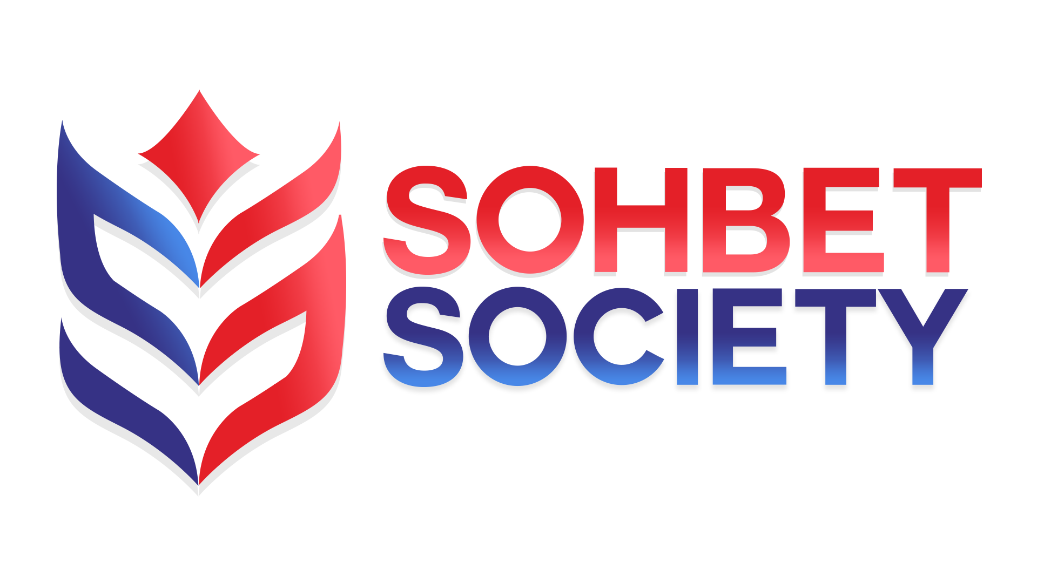

Sohbet Society
Reserves Policy

This policy will be reviewed on an ongoing basis, at least once a year. Sohbet Society will amend this policy, following consultation, where appropriate.

It is the policy of the charity to maintain free reserves at a level which balances our objectives to develop and support services with our need to remain financially stable.

A minimum level of free reserves equating to at least four (4) months of unrestricted expenditure is considered sufficient to cover management, administration and support costs and to respond to emergency needs which arise from time to time.

In addition, there is also a need to designate certain sums from free reserves for anticipated expenditure in the short to medium term.

This would generally be for capital expenditure and will be specified in the notes to the annual accounts.

It is anticipated that total free reserves, including designated funds, would be maintained at a level of six (6) months of unrestricted expenditure.

Equality and Diversity
We aim to be an organisation that values, recognises and responds to the diverse needs of members and those we serve. We adhere to the Equality Act 2010 and will not discriminate against any person or other organisation with particular reference to the protected characteristics

Monitoring and Review

Review Date | 29/03/2021
Next Review Date | 29/03/2022
Review Author | MB

