The role of Mesoscopic Phenomena on the Rheology of Unidirectional Thermoplastic Composite Flakes
1Y.M. Buser, 1,2G.A. Vincent, 1,2W. Ali, 2M. van Drongelen

1ThermoPlastic composites Research Center (TPRC), P.O. box 770, 7500 AT Enschede, The Netherlands 2Department of Mechanics of Solids, Surfaces and Systems (MS3), University of Twente, P.O. box 217, 7500 AE Enschede, The Netherlands

yannick.buser@tprc.nl

Keywords: discontinuous reinforcement, rheological properties, squeeze flow

Long fibre thermoplastics (LFTs) were introduced several decades ago to fill the gap between short fibre thermoplastics (SFTs) and continuous fibre reinforced polymers in terms of mechanical properties and shape complexity. With LFTs, featuring centimetre length fibres, a high level of function integration can be achieved while retaining a relatively long fibre length and thus increased mechanical performance compared to SFTs. [1,2] Although LFTs are in use for a long time now, understanding the flow behaviour during processing remains still a challenge. To obtain greater understanding of the processing of LFTs by compression moulding, it is an essential factor to know the viscosity over a range of process relevant shear rates. However, characterising the flow behaviour of fibre filled resin material is not straightforward and brings up a whole new range of challenges in terms of heterogeneity of the compound and its resulting properties. [2]

The objectives of the research were to obtain a deeper insight in (a) the rheological characterisation of LFTs and (b) the effect of mesoscopic phenomena influencing the melt flow behaviour, such as flake (re)orientation and deformation. For this purpose, axisymmetric squeeze flow experiments with constant mass were preformed, a rheological experiment in which a molten compound is compressed between two parallel plates and consequently squeezed out in-plane (Figure 1). [3] Circular specimens of unidirectional carbon fibre reinforced PES flakes with a fibre mass content of 30% have been compressed between the two heated plates at four different squeezing rates ranging between 0.0361 mm/s and 1 mm/s to 20% of their original height (Figure 2 and 3). The squeeze flow specimens contained fibre bundles of 11 mm in length and were investigated while featuring both a randomly oriented and initially aligned mesostructure.
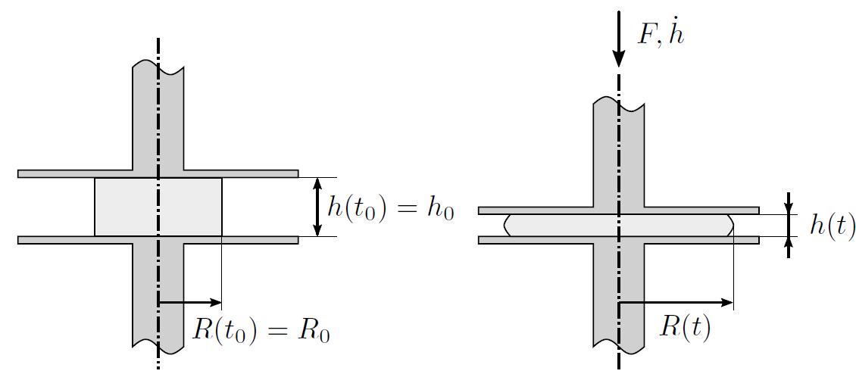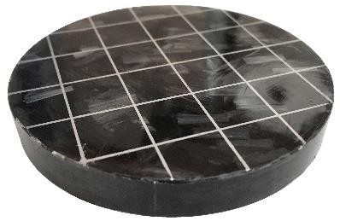

Figure 1 Schematic of the axisymmetric squeeze flow experiments
Figure 2 Initial squeeze specimen

Regarding the first objective, the measured force response and specimen height were taken as input of an analytical squeeze model [4] to characterise the macroscopic shear viscosity of the specimen according to a power-law dependency. Underlying modelling assumptions have been verified by observation of post-squeeze specimens and some additional experimental work. The extracted flow

Book of Abstracts SAMPE Benelux

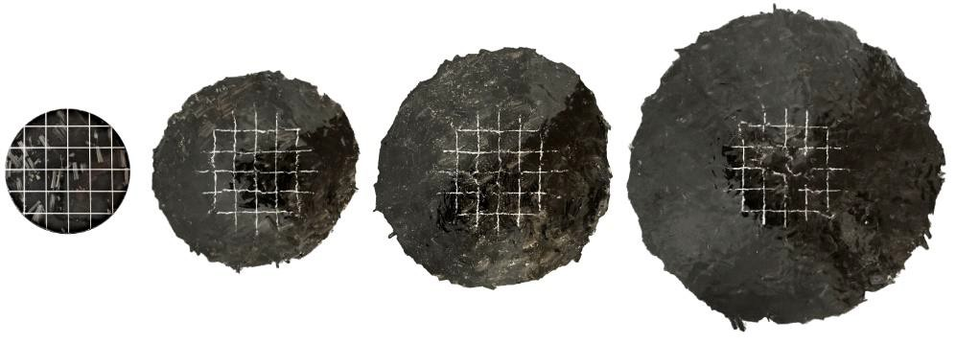
Figure 3 Increasing size of the
squeeze specimen with the course of the experiment

coefficients, being the power-law index 𝑛 and consistency index 𝑘, were successfully computed from the experimental data. Due to rapid reorientation of fibre bundles with the flow, no significant differences were noticed between an aligned and random mesostructure of the squeeze specimen. It is, however, shown that the consistency index 𝑘 rapidly increases with the course of the squeeze experiment (Figure 4).

With respect to the second objective, the rapid change in 𝑘 is explained by the evolving mesostructure of the squeeze specimen. From cross-sectional microscopy, it is observed that fibre bundles disintegrated into smaller sub-bundles or even single filaments along the flow distance. The decreasing average fibre bundle diameter 𝑑𝑓 leads to increased interactions with the suspending fluid and therefore increases the macroscopic viscosity of the flake suspension with the course of the squeeze experiment. Additionally, an analytical proportionality is found between 𝑘 and 𝑑𝑓 that supports this observation. Verification of the correlation between the found proportionality and the experimental data is subject to further research. In addition, the sensitivity of the disintegration phenomena to the input material should be investigated as well.
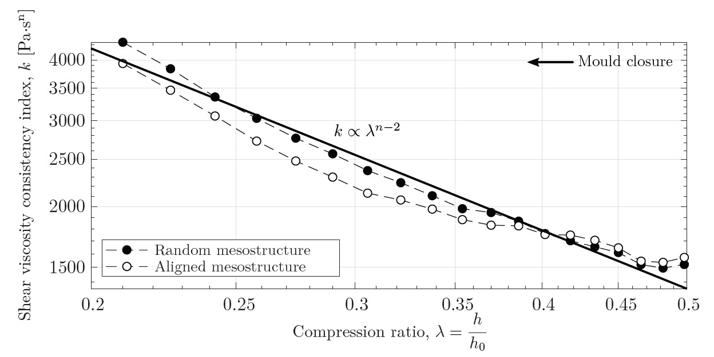
Figure 4 Fitted consistency index in a double logarithmic plot, indicating a proportionality equal to 𝜆𝑛−2.
Only a limited number of markers shown for clarity.

- M.I. Abdul Rasheed. Compression molding of chopped woven thermoplastic composite flakes. PhD thesis, University of Twente, Enschede, The Netherlands, 2016.
- K.B.T. Parthasarthy, S. Pillay, and U.K. Vaidya. Rheological characterization of long fiber thermoplastics - effect of temperature, fiber length and weight fraction. Composites Part A: Applied Science and Manufacturing, 40(10):1515-1523, 2009.
- J. Engmann, C. Servais, and A. Burbidge. Squeeze flow theory and applications to rheometry: A review. Journal of Non-Newtonian Fluid Mechanics, 132:1-27, 2005.
- R.B. Bird and O. Hassager. Dynamics of Polymeric Liquids: Fluid mechanics. Wiley, 1987.

