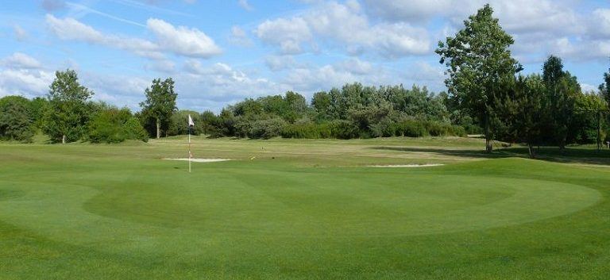

2018 EGC Presentation Tournament & Dinner

Dear Golf Club members,

It is my pleasure to invite you to participate in the Presentation Tournament and to attend the Presentation Dinner that will take place on Saturday 20th January 2018.

The Presentation Tournament format is played "against Par" with handicap adjustment.

Basically it can be seen as a modified stableford competition.

On a hole, a player gets a zero if he scores 2 stableford points

a + ( i.e. +1) if more than 2.
a - ( i.e. -1) if less than 2.

The winner is the one with the most positive score at the end.

The shot-gun start is at 12:00. Please use Proware in case you want to enter the Tournament or join us for the dinner, or both.
Entries for the Tournament and/or Dinner will close on Monday the 15th January at 12:00.
It is however recommended to enter for the dinner as early as possible.

Presentation Dinner

The Dinner and price giving will take place at restaurant of the Golf Club Rozenstein in Wassenaar, starting at 18:30 with a welcome aperitif. Dinner will start around 19:00.

Please find attached the menu for the evening. Please indicate your choices for the courses on the registration sheet below and return this sheet me by latest 15th January to allow the organization to finalize the arrangements with the restaurant.

The Cost for the dinner is € 34.00 per person, which includes an aperitif.
Please see the full menu below.
Drinks at the table will be at your own costs.

I hope that many active and non-active members can make a special effort to attend the Dinner and price giving, since this is the final opportunity to celebrate and acknowledge all winners and achievements from 2017.

Best regards

Klaus Ludwig

EGC Presentation Dinner Menu Options

Voorgerechten / Starter:

Taartje van Gepocheerde en Gerookte Zalm met Groene Kruiden Crème

or

Vegetarian: Kleine Carpaccio van Biet en Geitenkaas

Hoofdgerechten / Main Course Options:

Gebakken Runderlende met Pepersaus

or

Gebakken Kabeljauw met Mosterdschuim

or

Vegetarian: Risotto met Groene Asperges, Antiboise en Gepocheerd Ei

Dessert:

Huisgemaakte Tiramisu met een Bolletje Vanille Ijs

or

Cheese

Koffie incl.

Presentation dinner registration

 | Name  ………………. | Partner name  ………………
Starter
Fish
Vegetarian
Main
Fish
Meat
Vegetarian
Dessert
Sweet
Cheese

Please fill in your name(s) and mark your meal choice with an “X”. Send the completed form to:
klaus.ludwig@telfort.nl

Please register as soon as possible, but no later than
15th January 2018

