In the past there was a regular exchange competition between ESTEC Golf Club and Golfclub Kagerzoom (Warmond) and after some years of the event not taking place, it was decided to revive the tradition. Helma Nollen (who is a member at Kagerzoom), and your captain Garry organized the event over 2 Thursday afternoons, first at ESTEC, and then a week later at Kagerzoom.
The best 3 individual stableford points scores for each team, on each day, were added together to determine the eventual winning team.

On Thursday 18th July eight Kagerzoom players (unfortunately 2 others who were due to play had to drop out due to sickness & injury) came to ESTEC to join us on a warm afternoon. There were ten EGC players. The course was in good condition and everyone seemed to enjoy the golf.
Afterwards EGC offered a drink & snack which we enjoyed with our visitors on the terrace of Escape, and the scores were announced;
For ESTEC GC, the best 3 were Wil Spangenberg (40) Henk Wapstra (37) and Henk Doeswijk (37) = 114
For Kagerzoom the best 3 were Richard Kuipers (35) Wilfred Stikkleman (32) and Paul Somers (32) = 99
There were also prizes for 2 nearies – on Hole 1 won by Paul Somers, and on Hole 9 also won by Paul Somers.

A week later on Thursday 25th July, eleven EGC players visited Kagerzoom. To even the teams a little bit, Helma played for Kagerzoom this time bringing them to nine players.
The course is very nice and everyone seemed to have a good afternoons golf, and although most of us got caught in a heavy rain shower towards the end of our rounds it did not spoil our enjoyment of the afternoon.
We again enjoyed a drink and snacks kindly provided by Kagerzoom in the clubhouse afterwards, and the scores were announced;
For Kagerzoom the best 3 were Ton van Duin (40) Richard Kuipers (35) and Wilfred Stikkelman (34) = 109
And for ESTEC GC the best were Andreas Obst (35) Raffaele Tosellini (34) and Clare Bingham (33) = 102
Prizes were awarded for nearies on Hole 2 (won by Wilfred Stikkelman from the Yellow tee, and by Helma Nollen from the Red tee) and also for the longest drive won by Andreas Obst from the Yellow tee, by Brian Taylor from the Blue tee, and by Clare Bingham from the Red tee.

Clearly “home advantage” played out on both afternoons, with ESTEC GC 15 points up after the first day, and Kagerzoom being 7 points better on their home course. But ESTEC GC hung on to make an overall score of 216, with Kagerzoom totaling 208 over the 2 days. So ESTEC happily received the winners trophy.

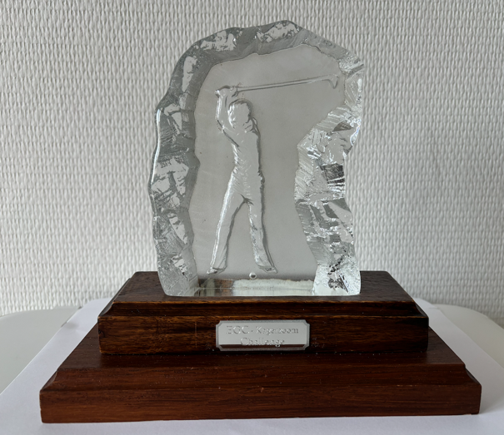

The challenge and the 2 rounds of golf with our friends from Kagerzoom were really enjoyable, and this competition will hopefully become an annual event once again.
Thanks to everyone from both clubs who participated.

Garry & Helma

