**Realsense set up tutorial**

Date: 20210825

Person: Dong Yi, (And others who want to improve it)

Links:

Link1: <https://github.com/IntelRealSense/librealsense/releases>

Link2: <https://github.com/IntelRealSense/librealsense/blob/master/doc/installation.md>

Link3: <https://github.com/IntelRealSense/realsense-ros/releases>

Link4: <https://github.com/IntelRealSense/realsense-ros#installation-instructions>

If you want to use Realsense camera with ROS. You need to install two packages (librealsense & realsense-ros). Before that, you need to determine the edtion of librealsense package and realsense-ros package you want. Using Link3 (figure below). Versions of the two packages must correspond to each other.

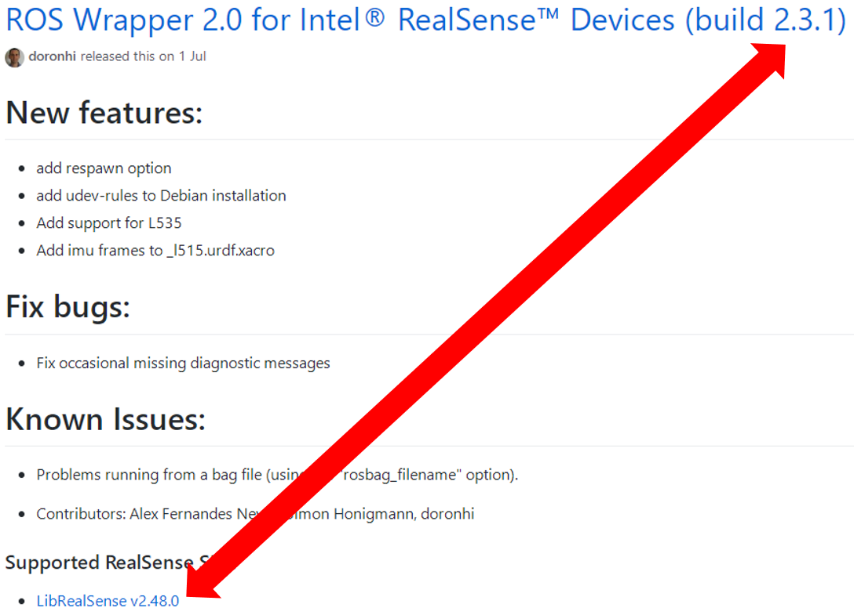

1 Download the librealsense package and realsense-ros package

Download librealsense package: Link1.

Download realsense-ros package: Link3.

2 Install librealsense package

Before installing librealsense package, you can check whether your platform meets the requirements of librealsense package (Link1).

Librealsense install method:

Method1: Using pre-build packages (not recommend)

<https://github.com/IntelRealSense/librealsense/blob/master/doc/distribution_linux.md>

Don’t recommend to use this method. This method can install the newest edition librealsense. And you can not find matching version realsense-ros package.

Method2: Using the source code packages (recommend)

Link2

2 Install realsense-ros package

Before installing realsense-ros package, you can check whether your platform meets the requirements of realsense-ros package (Link3).

Realsense-ros install method: Link4