

FY 2020 YHDP New Project Application

e-snaps Navigational Guide

Version 1


Table of Contents

Contents
Introduction 3
Objectives 3
Posted Resources 4
Overview of the Project Application Process 4
Overview of this Navigational Guide 4
Highlights in e-snaps for the FY 2020 CoC YHDP Program 6
Helpful Reminders from Prior Years 7
Accessing e-snaps 8
Existing Users 8
New e-snaps Users 8
Give Staff Access to Your Organization’s e-snaps Account 9
Project Applicant Profile 10
Establish the Project Application 11
Funding Opportunity Registration 11
Creating the Project Application Project 13
Submissions 16
FY 2020 Project Application 17
Accessing the YHDP New Project Application 18
Accessing the Special YHDP Activities Screen 20
8B. Submission Summary 24
Submitting the Project Application 27
Exporting to PDF 27
Troubleshooting when you cannot submit the Project Application 28
Updating the Applicant Profile 30
Next Steps 31

Introduction

Welcome to the YHDP New Project Application Navigational Guide. This navigational guide covers important information about accessing and completing the Project Application for YHDP new projects.

The organization submitting the Project Application for funding is the Project Applicant. Project Applications are submitted to the Continuum of Care (CoC) Collaborative Applicant, which submits the entire funding application to HUD on or before the CoC Program Competition deadline.

Prior to using this navigational guide, Project Applicants must have completed the Project Applicant Profile. In order to meet that requirement, the Project Applicant Profile's "Complete" button must be selected during the competition period. A separate Project Applicant Profile Navigational Guide is available at:

- https://files.hudexchange.info/resources/documents/Project-Applicant-Profile-Navigational-Guide.pdf.

All Project Applicants are strongly encouraged to read the FY 2020 YHDP NOFO at:

- https://www.hudexchange.info/programs/yhdp/fy-2019-2020-application-resources/.

This navigational guide supplements the New Project Application Detailed Instructions.

Have a question?

The e-snaps AAQ on HUD Exchange is no longer active. For questions related to the FY220 NOFO or navigating e-snaps, send questions to the appropriate HUD.gov email address:

- YouthDemo@hud.gov for questions about the NOFO, competition applications, questions about e-snaps technical issues, including creating an individual user profile, lockouts/password resets, requesting access to a CoC’s or project applicant’s e-snaps account, navigating e-snaps, updating the Applicant Profile, identifying the funding opportunity, creating a project, and accessing the application on the Submissions screen.

Objectives

By the end of this module, you will be able to do the following:

- Access e-snaps

- Register for the FY 2020 YHDP New Project Application funding opportunity

- Create a YHDP New Project Application under the funding opportunity

- Enter a YHDP New Project Application from the “Submissions” screen

- Complete and submit a YHDP New Project Application to the Collaborative Applicant

- Only if needed, coordinate with the Collaborative Applicant prior to the submission deadline to make changes to a Project Application in e-snaps

Posted Resources

HUD has determined that some CoC and e-snaps related resources need to be posted to HUD.gov as HUD’s official website, rather than to the HUD Exchange, which focuses on technical resources for communities and grant recipients. FY 2020 YHDP NOFO information (e.g., detailed instructions), including the FY 2020 e-snaps Navigational Guides, will be shared via email with communities and TA.

Overview of the Project Application Process

FY 2020 Project Applicants must complete a Project Applicant Profile and Project Application using e-snaps, a web-based portal accessible at:

- https://esnaps.hud.gov/.

Each Project Applicant must complete a Project Applicant Profile and submit its Project Application(s) to the applicable CoC in e-snaps by the local submission deadline established by the CoC.

Overview of this Navigational Guide

The organization of material in this navigational guide corresponds with the different parts of the Project Application process, and the navigational steps follow the progression of screens in e-snaps.

- Accessing e-snaps. All e-snaps users need usernames and passwords to log in to e-snaps. In order to see an organization's Project Applicant Profile and Project Applications, the e-snaps user needs to be associated as a "registrant" with the organization's e-snaps account. This section identifies the steps required to create user profiles and add/delete registrants.

- Project Applicant Profile. Project Applicants must review the Project Applicant Profile, update the information as needed, and select the "Complete" button in order to proceed with the Project Application process.

- The Project Applicant Profile section of this navigational guide briefly highlights key information for Project Applicants that are getting ready to complete their Project Applications.

- For instructions on completing the Project Applicant Profile, go to the Project Applicant Profile navigational guide at:

https://files.hudexchange.info/resources/documents/Project-Applicant-Profile-Navigational-Guide.pdf

- Establishing and accessing the Project Application. After the Project Applicant Profile is complete, Project Applicants need to follow a series of steps in order to access the Project Application screens. The steps discussed in this section include registering the Project Applicant for the FY 2020 YHDP New Project Application funding opportunity, creating an FY 2020 project, and accessing the Project Application screens.

- Project Application. After accessing the FY 2020 YHDP New Project Application, Project Applicants will complete a series of screens asking for information about the project for which they are applying for funding. This section provides instructions on how to complete each screen. After providing all of the required information, the Project Applicant will submit the Project Application to the Collaborative Applicant via e-snaps.

- Submitting the Project Application. This section discusses what occurs after the Project Applicant submits the YHDP New Project Application in e-snaps to the Collaborative Applicant. The Collaborative Applicant will review and either approve and rank or reject the Project Application.

- Amending the Project Application. If changes need to be made to the Project Application, the Collaborative Applicant will amend the project back to the Project Applicant. Notification for amending a project back to the applicant occurs outside of e-snaps.

Amending an If the CoC amends the project application back to the Project Applicant for

Application revision or correction, it is the Project Applicant’s and Collaborative Applicant’s responsibility to ensure the Project Application is resubmitted in e-snaps to the CoC.

Highlights in e-snaps for the FY 2020 YHDP Program

This section highlights several items in e-snaps this year.

- Racial Equity

Questions related to Racial Equity have been added throughout the project application. Please answer these questions to the best of your ability.

- Special YHDP Activities. This is the first year the Special YHDP Activities are available under the YHDP New application. Applicants will find a screen consisting of a list of checkboxes. Please select Special YHDP Activities that you organization will find applicable to your project

- Unique Entity Identifier (UEI).
Starting on April 4th, across all Federal awards, the DUNS number will be replaced with what is called the Unique Entity Identifier (UEI). The UEI is a requirement for all federal grantees. Below are a few tips on how to find your organizations UEI number:

If your entity is already registered in SAM.gov, your Unique Entity ID (UEI) has already been assigned and is viewable in SAM.gov. This includes inactive registrations. The Unique Entity ID is currently located below the DUNS Number on your entity registration record. Remember, you must be signed in to your SAM.gov account to view entity records

Follow this link: https://www.fsd.gov/gsafsd_sp?id=gsafsd_kb_articles&sys_id=a05adbae1b59f8982fe5ed7ae54bcbba to learn how to find your unique UEI on SAM.gov

Follow this link: https://www.fsd.gov/sys_attachment.do?sys_id=3866d0061b13b8106397ec21f54bcb72 on how to get a UEI ID if you currently do not have one.

Helpful Reminders from Prior Years

This section highlights several items that are not new but are included as useful reminders.

- HUD 2880 (Applicant/Recipient Disclosure/Initial Report). As with prior years, the HUD Form 2880 is no longer uploaded as an attachment. This form is related to the Project Applicant Profile and the fields are not editable in the forms in the Project Applications. For instructions on completing the HUD Form 2880 in both the Project Applicant Profile and the Project Applications (new, renewal, YHPD, CoC planning, and UFA costs), refer to the following resource:

  - https://files.hudexchange.info/resources/documents/How-to-Complete-the-HUD-Form-2880-in-e-snaps.pdf.

- Prepopulating Data from the Project Applicant Profile. Some data will automatically populate fields on several screens from the information entered into your Project Applicant Profile. If this information is incorrect, changes can be made by exiting the application and returning to the Project Applicant Profile.

- The "Project Application"

  - The Project Application includes the information submitted by renewal and new Project Applicants for funding consideration.

- Applicant Field and Dropdown Menu. When e-snaps users log in to the system, they will see an "Applicant" field at the top of the screen. This field identifies the organization's account in which the user is working.

Users with e-snaps access to more than one organization's account will see a dropdown menu listing two or more organizations. This group of e-snaps users includes staff persons who work on multiple applications (e.g., a staff person at an agency that serves as the Collaborative Applicant as well as a Project Applicant submitting one or more Project Applications).

This feature appears when working on the Applicants, Funding Opportunity, Projects, and Submissions screens. Only the items (e.g., Projects) pertaining to the Applicant listed in the field appear on the screen. Users must ensure they are working in the correct Applicant account.

Accessing e-snaps

The Project Application is submitted electronically in e-snaps during the annual competition under the FY 2020 YHDP Program. 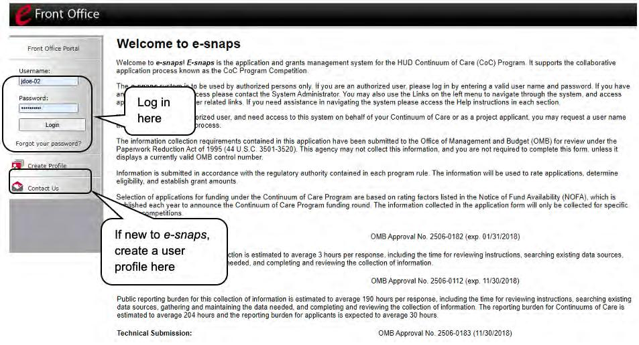

NOTE: Each e-snaps user must have his or her unique log-in credentials.

Preferably, each organization will have at least two people with access to e-snaps—the Authorized Representative and one or more additional staff.

Existing Users

Steps

- Direct your Internet browser to https://esnaps.hud.gov/.

- On the left menu bar, enter your username and password. You will then enter e-snaps and arrive at the "Welcome" screen.

- If you forgot your password, select "Forgot your password?" under the "Login" button.

New e-snaps Users

Steps

- Create an e-snaps username and password by selecting the "Create Profile" link.

- Log in as instructed under Existing Users above.

Give Staff Access to Your Organization’s e-snaps Account

Having a user profile enables a person to access e-snaps. However, only individuals who have been associated with the organization as a registrant (also referred to as registered users) have the ability to enter information in the Project Applicant Profile and Project Applications associated with the organization.

For information on how to add and delete users, refer to the “Give Staff Access to

Your Organization’s e-snaps Account” resource at:

- https://files.hudexchange.info/resources/documents/Give-Staff-Access-to-Your-Organizations-e-snaps-Account.pdf

Project Applicant Profile

Project Applicants must complete the Project Applicant Profile before moving forward in the Project Application process. To complete the Project Applicant Profile, the Project Applicant needs to ensure the data entered in the profile screens is accurate and must select the “Complete” button on the “Submission Summary” screen.

This section in the YHDP New Project Application Navigational Guide highlights key information needed to successfully complete this step. It does NOT provide detailed instructions.

For detailed instructions, see the Project Applicant Profile navigational guide at:

• https://files.hudexchange.info/resources/documents/Project-Applicant-Profile-Navigational-Guide.pdf

- Access the Project Applicant Profile. To access the Project Applicant Profile, log in to e-snaps, select "Applicants" on the left menu bar, ensure that the correct Project Applicant name in the "Applicants" field at the top left side of the screen is selected, and select the orange folder to the left of the Project Applicant name on the screen.

- Organizations that are Collaborative Applicants and Project Applicants. If the organization applying for funding as a Project Applicant is also serving as the Collaborative Applicant, the organization will have two Applicant Profiles—one for the Project Applicant and one for the Collaborative Applicant.

The "Applicant" field dropdown menu at the top left side of the screen contains the list of Applicants that a user can access. If you have issues with finding the correct Project Applicant, submit an email to e-snaps@HUD.gov. The e-snaps AAQ on HUD Exchange is no longer active.

- First-time Applicant. If an organization is new to e-snaps (i.e., submitting a Project Application for the first time), the organization must establish itself as a Project Applicant in e-snaps. Review the Project Applicant Profile Navigational Guide at:

- https://files.hudexchange.info/resources/documents/Project-Applicant-Profile-Navigational-Guide.pdf

An organization will establish itself as a Project Applicant in e-snaps one time only.

If you are a Collaborative Applicant and a Project Applicant applying for YHDP New project funds, you must have two separate Applicant Profiles—a Collaborative Applicant Profile and a Project Applicant Profile.


Contact the HUD Exchange Ask-A-Question if you need assistance at:

- https://www.hudexchange.info/get-assistance/my-question/.

Establish the Project Application

After the Project Applicant Profile is completed, Project Applicants can move to the next steps required to establish and access the Project Application screens. This section covers the following:

- Funding Opportunity Registration

- Creating projects

- Accessing Project Applications from the Submissions screen

Funding Opportunity Registration

All Project Applicants must register the organization for the FY 2020 YHDP New Project Application funding opportunity. Registering for the funding opportunity enables Project Applicants to apply for funds during the FY 2020 YHDP Program.

Terminology "Registering" in this context means "indicating your intent to apply."

"Funding Opportunity" refers to “the type of grant.” There are options when you select this screen. They include YHDP New, CoC Planning, New, Renewal, and UFA Costs.

On this screen, you are indicating your intent to apply for a specify type of grant. 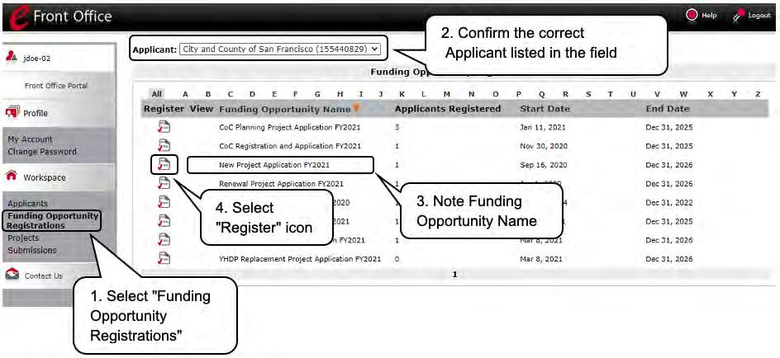

Steps

- Select "Funding Opportunity Registrations" on the left menu bar.

- The "Funding Opportunity Registrations" screen will appear.

- Select the "Register" icon next to "YHDP New Project Application FY 2021."

- The "Funding Opportunity Details" screen will appear.

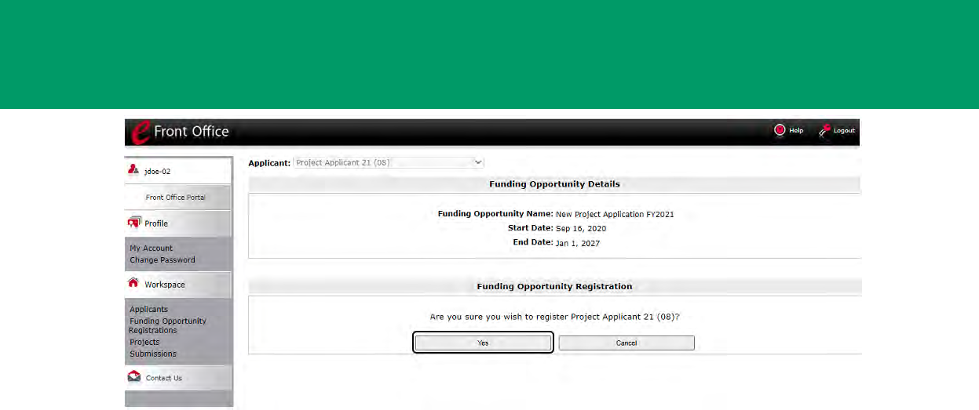

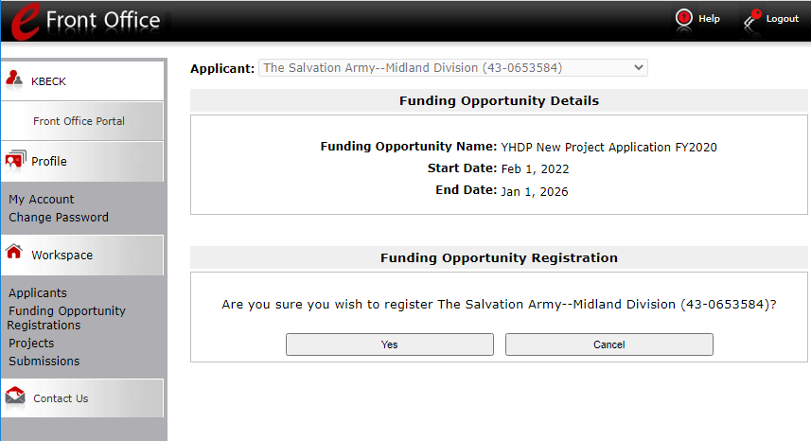
Steps

- When the question appears asking if you want to register the Project Applicant for the funding opportunity, select "Yes" to confirm that you want to register your organization.

- The screen will then indicate that the Project Applicant has been registered.

- Select the "Back" button to return to the "Funding Opportunity Registrations" screen.

Remember, the "Applicant" field with the dropdown menu located at the top left side of the screen identifies the Applicant Profile under which you are working.

Please ensure you are working under the correct one.

The following image shows the screen that appears when the organization has successfully registered for the New Project Application funding opportunity.

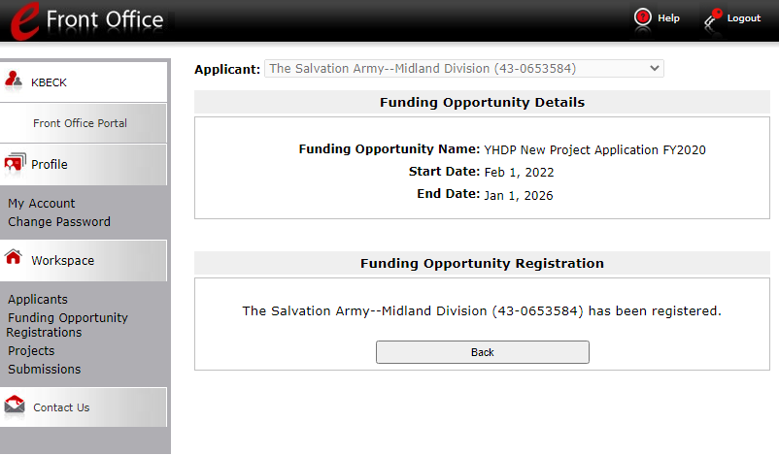

Creating the Project Application Project

Project Applicants must create a project for the YHDP New Project Application in e-snaps on the "Projects" screen. Creating a project is an intermediate step. Organizations do NOT enter the Application from the “Projects” screen to complete the Application screens; instead, they access the application from the "Submissions" screen.

Once the Project Applicant "creates" the project, it will appear on this screen and the term "New Project Application" will appear under the "Funding Opportunity Name" column.

Terminology "Creating a Project" means "giving the project application a name.”
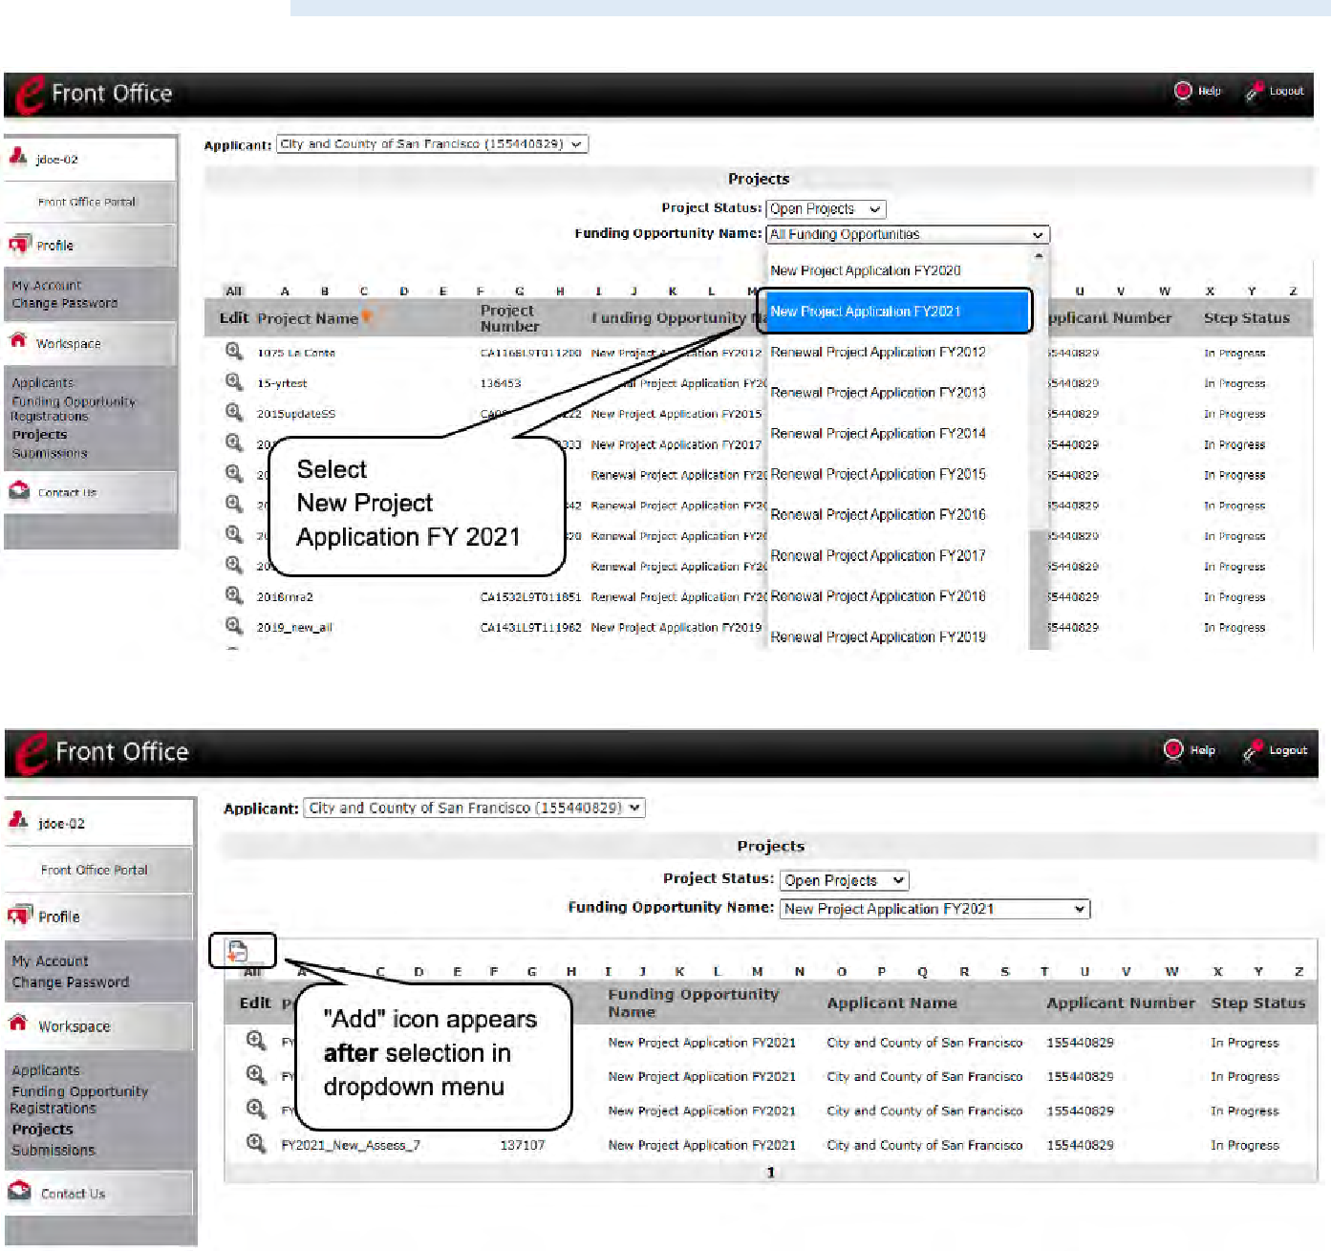

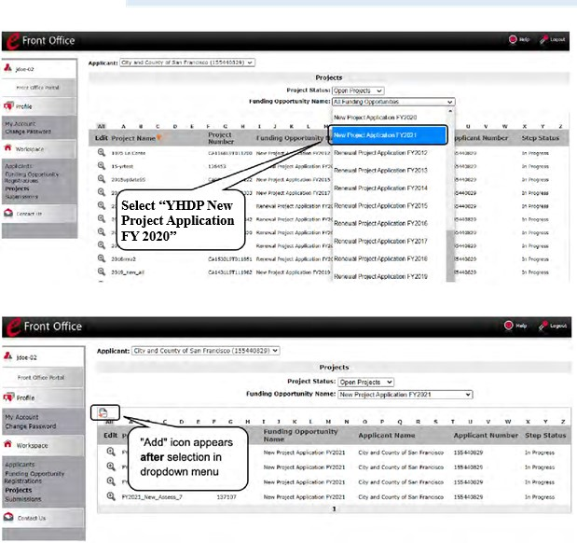
Steps

- Select "Projects" on the left menu bar.

- The "Projects" screen will appear.

- Select "YHDP New Project Application FY 2020" from the "Funding Opportunity Name" dropdown.

- The screen refreshes and an "Add" icon appears on the left side of the screen above the column headings.
- Select the "Add" icon.

- The "Create a Project" screen will appear.

Remember, the "Applicant" field with the dropdown menu located at the top of the screen identifies the Applicant Profile under which you are working.

Please ensure you are working under the correct Project Applicant.

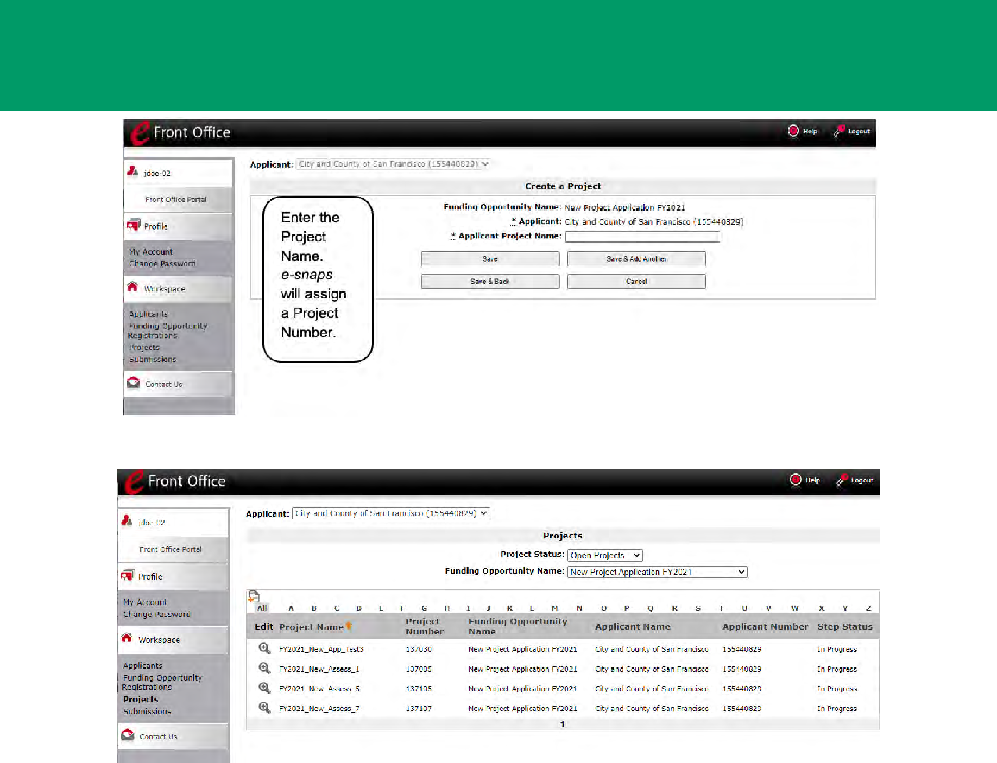

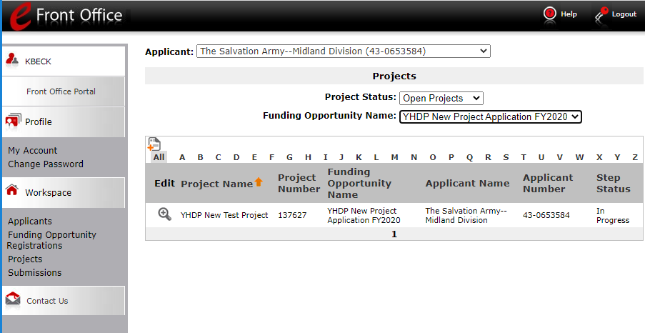

Steps

- On the "Create a Project" screen, the Project Applicant Name will be pre-populated.

- In the "Applicant Project Name" field, enter the name of the project.

- You should enter the name that you want to appear in the grant award letter.

- Select "Save & Back" to return to the "Projects" screen.

- The project name is listed in the menu.

- Select the "View" icon to view project details; however, it is not necessary to enter any notes on that page.

Submissions

After completing the Project Applicant Profile, registering for the Funding Opportunity, and creating the YHDP New Project Application project, Project Applicants may now enter the Project Application and complete the screens. You must access the YHDP New Project Application from the "Submissions" screen.

Terminology "Submissions" refers to both submitted project applications and project applications that are in progress to be submitted.

This screen also includes applications that are created by mistake and are not intended to be submitted.

Once you have created a project on the Projects screen and it appears here, you cannot delete it. You can only rename it.

Steps

- Select "Submissions" on the left menu bar.

- The "Submissions" screen will appear.

- Locate the Project Application project you established.

  - Option: Use the "Submissions Filters." Select the project name in the “Project Name” field. Then select the "Filter" button to single out your project(s).

  - Option: Select "Clear Filters" on the top left of the "Submissions Filters" box. Then, review the "Funding Opportunity Name / Step Name" column for "YHDP New Project Application."

- Continue with the instructions in the next section for the completing the New Project Application. 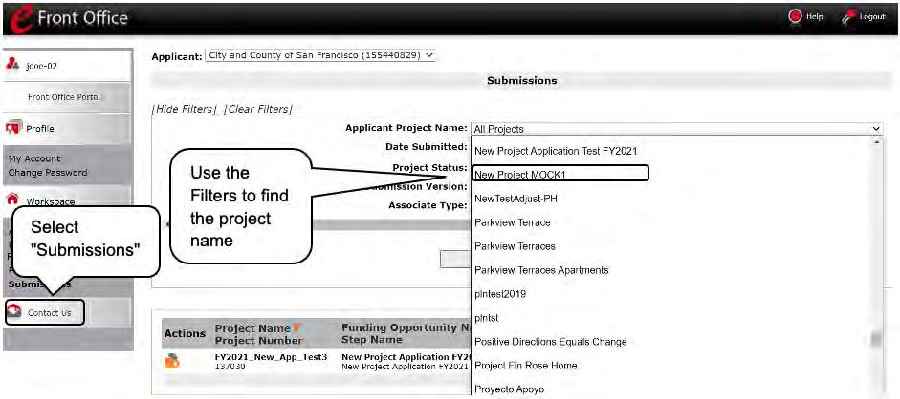

FY 2020 Project Application

This section identifies the steps for completing the New Project Application screens in e-snaps.

NOTE:
NOTE: | Some data may pre-populate from the Project Applicant Profile (i.e., e-snaps will
 | bring it forward). Review the pre-populated data. If any information is incorrect,
 | you must go back and correct it in the Project Applicant Profile.
 | If you are in the Project Application and you need to update the Project Applicant
 | Profile do not use the "View Applicant Profile" link on the left menu bar. Instead:
 | • Select "Back to Submissions List." Select "Applicants" on the left menu bar,
 | and select the orange folder next to the Applicant name.
 | • Ensure that the Applicant Profile is in "edit" mode.
 | • Make the appropriate corrections as needed, and select “Save” at the bottom
 | of the screen after you make each revision.
 | • Once you have made all of the necessary corrections to your Project
 | Applicant Profile, continue to the “Submission Summary” screen and select
 | “Complete.”
 | • When you return to the Project Application, the screen will show the
 | corrected information.
 | If the corrected information does not populate the Project Application, do the
 | following:
 | • Log out of e-snaps.
 | • Log back in and navigate to the screen in the Applicant Profile where
 | information needs to be corrected. If the information is incorrect, correct it
 | and Save. If the information is correct, then edit it to something that is
 | incorrect, save it, then change it back, and save it.
 | • Navigate to the "Submission Summary" and select "Complete.
 | • Log out of e-snaps.
 | • Log in again. Navigate to your Project Application. The information should be
 | updated.
 | Select “Save” at the bottom of the screen after you make each revision. Once
 | you have made all of the necessary corrections to your Project Applicant Profile,
 | proceed to the “Submission Summary” screen and select “Complete.” When you
 | return to the Project Application, the screen will show the corrected information.
 | Review the instructions in the Submitting the Project Application section in this
 | guide.

Accessing the YHDP New Project Application

Access the New Project Application through the "Submissions" screen.

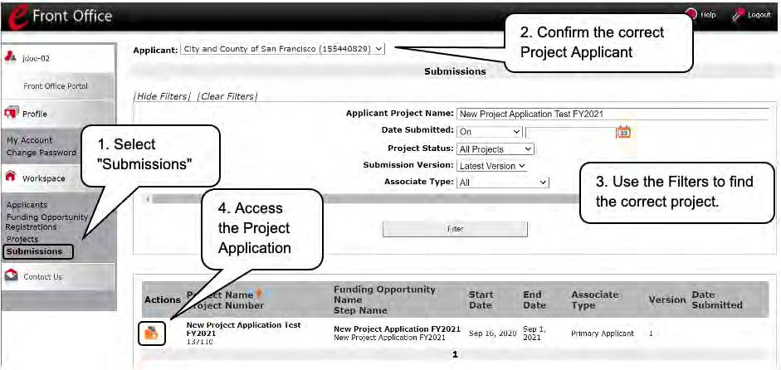Steps

- Select "Submissions" on the left menu bar.

- The "Submissions" screen will appear.

- Select the "Folder" icon to the left of the Project Application Name you established with the Funding Opportunity Name "YHDP New Project Application FY 2020."

- The "Before Starting" screen will appear.

Accessing the Special YHDP Activities Screen
The Special YHDP Activity screen lists all the Special YHDP Activities applicants can apply for in the YHDP New project. The applicant is not required to select a Special YHDP Activity. However, if the applicant wants to, they must select “Yes” from the dropdown.

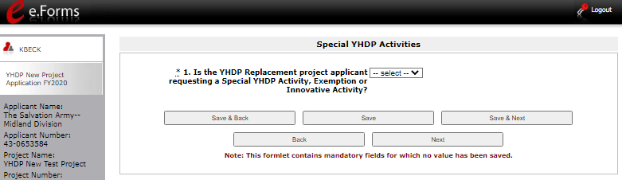

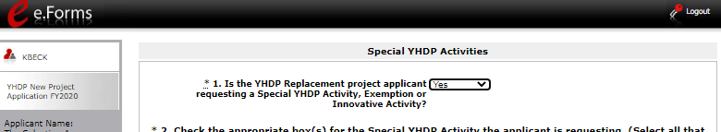

Once “Yes” is selected from the dropdown menu, applicants are given the full list of Special YHDP Activities.

Below is what the Special YHDP Activity screen in e-snaps will look like. This screen is editable.

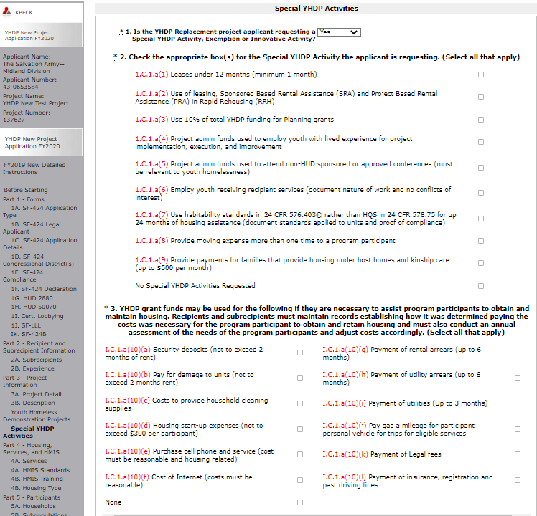
If Yes selected, questions 2 to 5 will appear.

The applicant will select a Special YHDP Activity for their project by clicking on the checkbox next to the Special YHDP Activity. Questions 2 and 3 above do not require additional documentation in e-snaps. The text in red references where this Special YHDP Activity can be found in the YHDP NOFO or Appendices.

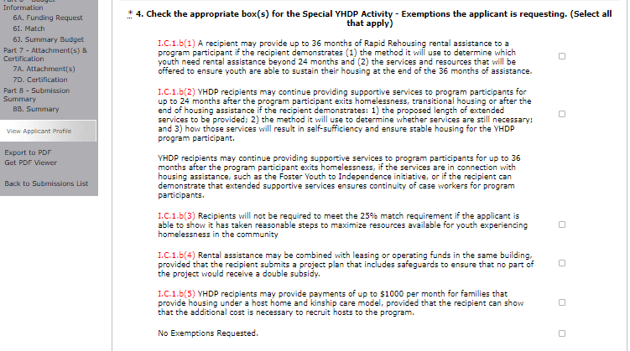
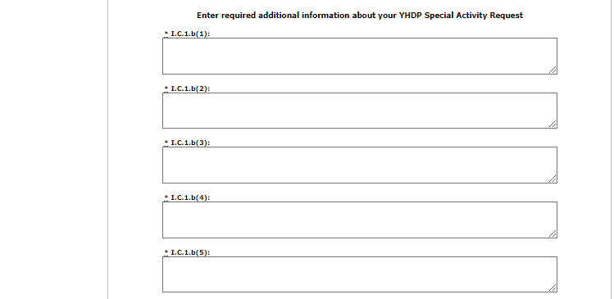
Textbox will appear for each Special YHDP Activity under Question 4. A detailed explanation is required
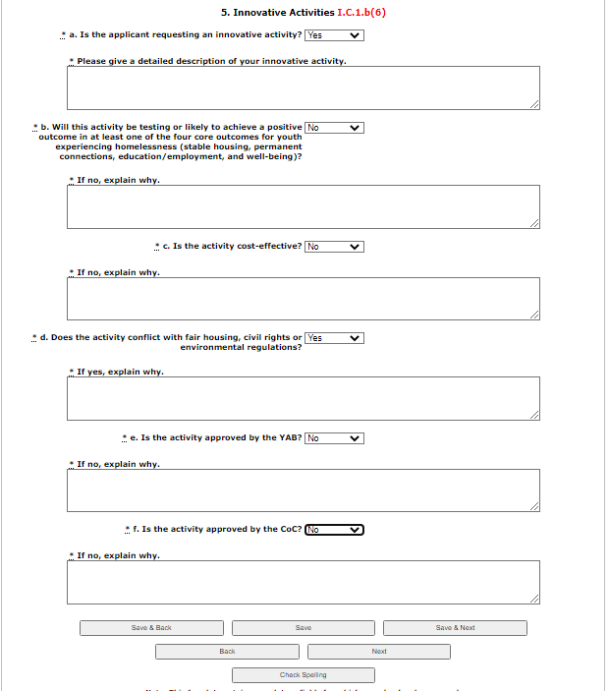
If yes selected, b. to f. will appear.

The following Special YHDP Activities/Innovative Activity (Questions 4 &5) will require additional information in e-snaps. If this is not included, the Special YHDP Activity may not be accepted.
If you have questions on Special YHDP Activities, please contact the Youth Demo mailbox at YouthDemo@hud.gov.

8B. Submission Summary

Once the required information has been entered and the required attachments have been uploaded, the Project Applicant needs to select the "Submit" button on the "Submission Summary" screen.

The "Submission Summary" screen shows the Project Application screens. In the "Last Updated" column, the system will identify the following:

- A date if the screen is complete

- "No Input Required" if there is no input required

- "Please Complete" if more information is needed

Users can go back to any screen by clicking on the screen name on the left menu or on the screen name in the Submissions list itself. Remember to select "Save" after making any changes.

NOTE: The "No Input Required" status on the Submission Summary indicates that additional information for that screen is not required for the Project Applicant to continue to the next step in e-snaps.

In the context of this navigational guide, the Project Applicant may continue to the next steps in the Project Application process.

HUD, however, may require you to address the particular item prior to entering into a grant agreement if conditionally awarded.

The "Submit" button is located at the bottom of the screen under the navigation buttons. The "Submit" button will be active if all parts of the Project Application are complete (and have a date) or state "No Input Required."

After submitting the Project Application, Project Applicants should notify the Collaborative Applicant. Notification is recommended to provide a heads-up to the Collaborative Applicant that the application is ready for their review and ranking.

The following image shows the Project Application "Submission Summary" screen with items that still need to be completed. Note that the "Submit" button is gray-shaded, and you cannot select it. 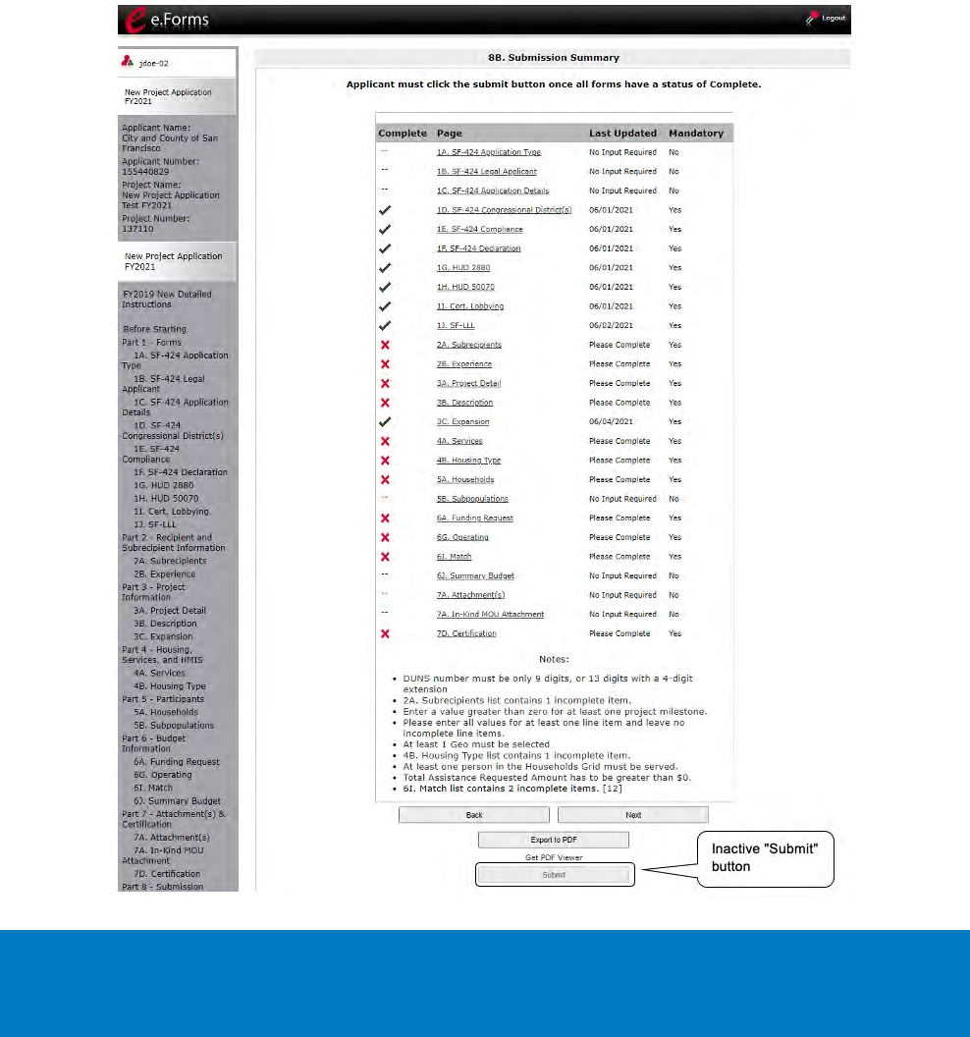

Steps

- For the item(s) that state "Please Complete," either select the link under the "Page" column or select the item on the left menu bar.

- Complete the screen, saving the information on each screen.

- When you have an active "Submit" button, continue to the next section.

Submitting the Project Application

The following image shows an active "Submit" button on the Project Application "Submission Summary."

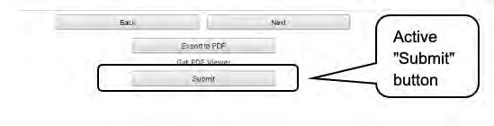

Steps

- If you are not already on the "Submission Summary" screen, select it on the left menu bar.

- Select the "Submit" button.

- Notify the Collaborative Applicant that you have submitted your Project Application.

The following image shows the completed Project Application “Submission Summary” screen. Note that the "Submit" button is no longer active, but instead appears gray-shaded. The screen is marked "This e.Form has been submitted."
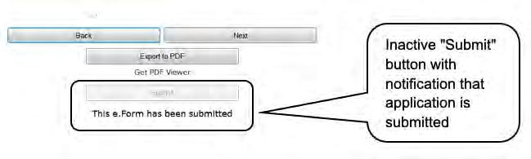

Exporting to PDF

Project Applicants can obtain a hard copy of the Project Application using the "Export to PDF" button located at the bottom of the Submission Summary screen under the navigation buttons.
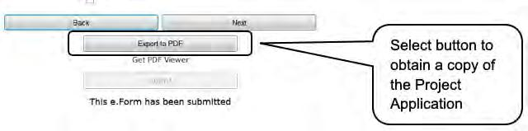

Steps

- Select the "Export to PDF" button.

- On the "Configure PDF Export" screen, select the screen(s) you would like included.

- Select "Export to PDF."

Troubleshooting when you cannot submit the Project Application

Applicants may encounter issues when trying to submit the Project Application. If the “Submit” button is gray (i.e., “grayed-out”), it is not active and you cannot select it. You will not be permitted to complete your form at this time. The “Submit” button will appear gray if information is missing on any of the required Project Application forms or in the Applicant Profile.

The following image shows the New Project Application "Submission Summary" screen with items that still need to be completed. Note that the "Submit" button is gray-shaded, and you cannot select it.

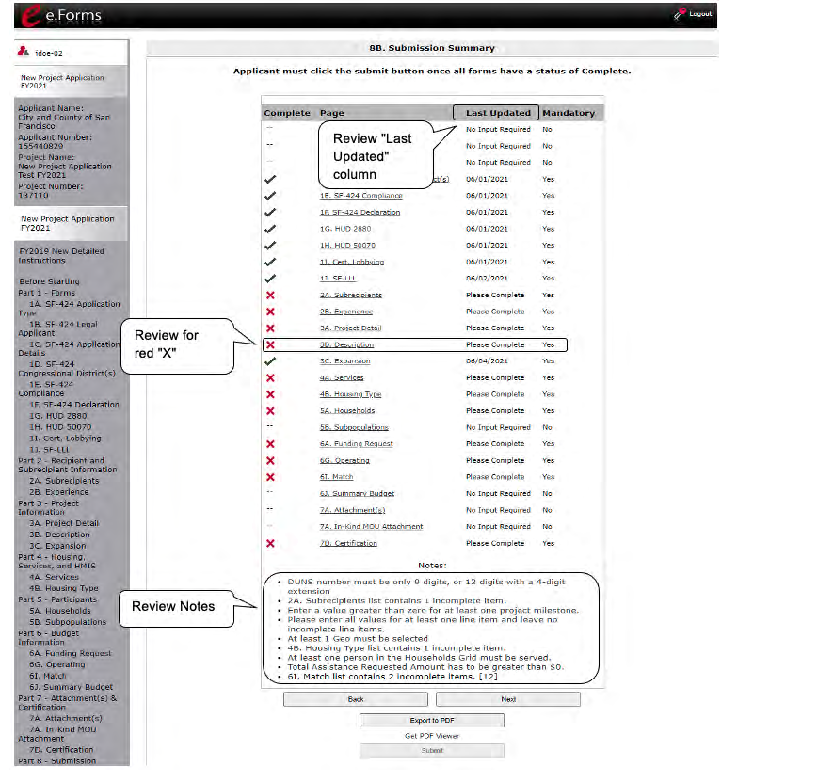
Steps

- Review your Submission Summary screen to determine which Project Application form needs to be completed. For the item(s) that state "Please Complete," either select the link under the "Page" column or select the item on the left menu bar.

- Complete the screen, saving the information on each screen.

- Return to the Submission Summary screen and select the "Submit" button.

What the “Last Updated” column tells you. A date identifies a form with complete information for all required fields. It is the most recent date on which the completed form was saved.

- "Please Complete” identifies a form with information missing in one or more required fields.

- “No Input Required” identifies the form that are not required for completion by all projects. You are strongly encouraged to double-check these forms to ensure that all appropriate project information is completed.

What the “Notes” section at the bottom of the screen tells you. Notes are not a standard section on the “Submission Summary” screen, so you will not see this section all the time.

- If Notes appear on the screen, they are located under the two-column list and above the navigational buttons.

- The Notes provide information on the errors in the Project Application. Some Notes include a link to the applicable form and error(s).

NOTE: If you are still unable to submit the New Project Application after following these instructions, please submit a question to the HUD Exchange Ask A Question, at: https://www.hudexchange.info/get-assistance/my-question/, under the e-snaps Reporting System.

In the question field, please provide specific details regarding the issue you are encountering while trying to submit and provide a screenshot whenever possible.

Updating the Applicant Profile

If an Applicant needs to edit the Project Applicant Profile in order to correct information, the Applicant must do the following:

Steps

- Select “Back to Submissions List.”

- Select “Applicants” in the left menu bar.

- Ensure your Applicant name is selected in the dropdown menu at the top of the screen.

- Select the "Open Folder" icon to the left of the Applicant Name.

- Select “Submission Summary” on the left menu bar.

- Select the “Edit” button.

- Navigate to the applicable screen(s), make the edits, and select “Save.”

- Select “Submission Summary” on the left menu bar and select the “Complete” button.

- Selects “Back to Applicants List” on the left menu bar.

- Select “Submissions” on the left menu bar.

- Select the orange folder to enter the Project Application. The change should have pulled forward.

NOTE: The “View Applicant Profile” link in the left menu bar, within the project application, is intended only to view the Project Applicant Profile and not to make any updates.

Next Steps

Congratulations on submitting your YHDP New Project Application!

For additional resources go to the HUD.gov and e-snaps webpages at:

- https://www.hud.gov/program_offices/comm_planning/coc/competition

- https://www.hudexchange.info/programs/e-snaps/

- Email any question to youthdemo@hud.gov

