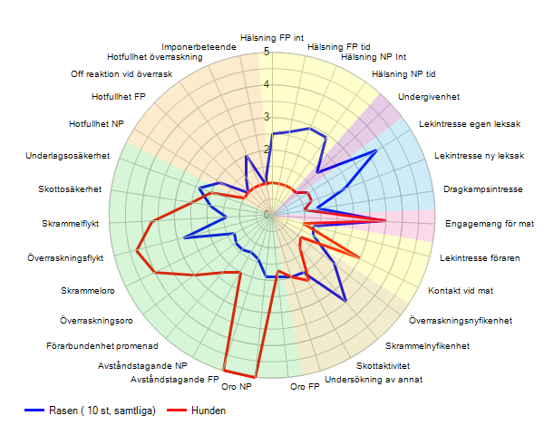

**Testprotokoll!**