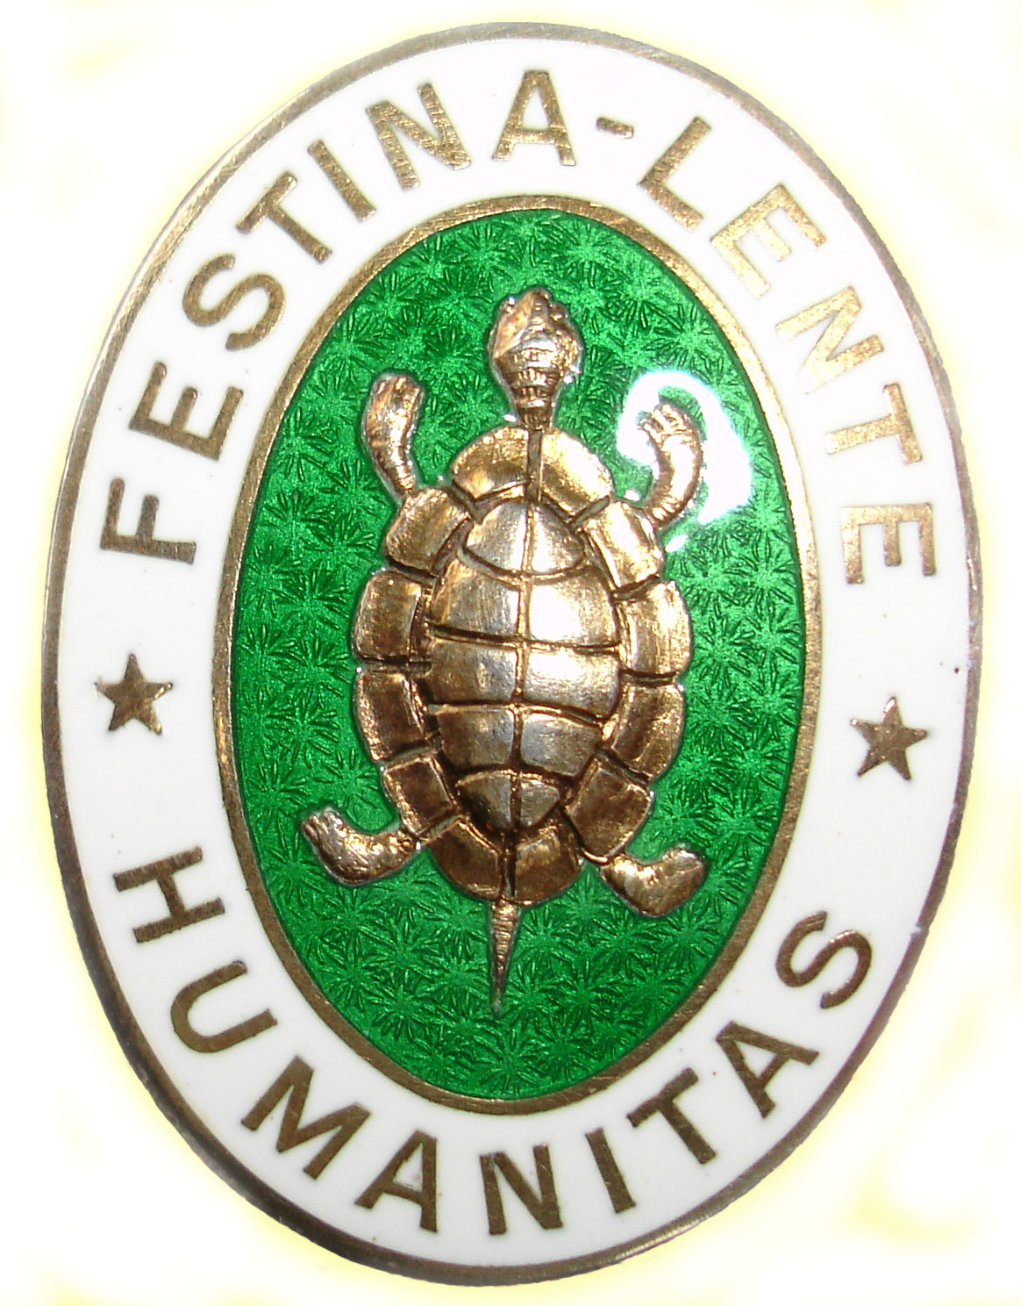 | Humanitas Open 2018

 | Navn | Handikap | Eiere
1 | Abrahamsen, Sigbjørn | 57 | Young Guns
2 | Andersen, Velle | 84 | Skomvær
3 | Busk, Jørgen | 47 | NBI
4 | Christoffersen, Haakon | 88 | DRIBB
5 | Davidsen, Geir | 95 | Solstua
6 | Finne, Henrik | 43 | NBI
7 | Gundersrud, Tom | 70 | Young Guns
8 | Haglund, Per Herman | 50 | Young Guns
9 | Hannemyr, Trond | 56 | NBI
10 | Helstedt, Geir | 35 | Esben Storvand
11 | Hohner, Arvid | 36 | Young Guns
12 | Holm-Jørgensen, Per | 36 | DRIBB
13 | Holt, Knut Olav | 35 | Young Guns
14 | Immerstein, Morten | 35 | Jan Løkling
15 | Jacobsen, Nils Alf | 74 | DRIBB
16 | Johannessen, Paul Erik | 45 | Young Guns
17 | Karlsen, Petter | 60 | Young Guns
18 | Kongsgaarden, Per | 35 | NBI
19 | Larsen, Knut B. | 70 | NBI
20 | Larsen, Rune | 61 | Skomvær
21 | Larsen, Sjur G. | 77 | DRIBB
22 | Larsen, Thorleif (Totto) | 41 | Young Guns
23 | Lillestøl, Kjell | 144 | Per Erik
24 | Lundgren, Jarle | 103 | Young Guns
25 | Løvig, Alexander | 89 | Hans Arve
26 | Mandal, Arvid | 68 | Young Guns
27 | Mathisen, Svein | 50 | Young Guns
28 | Naper, Terje | 35 | Six Pack
29 | Olsen, Stian | 35 | Young Guns
30 | Olsen, Trond | 35 | NBI
31 | Pettersen, Jarann | 49 | DRIBB
32 | Prestvik, Oddvar | 45 | Kjell Lillestøl
33 | Ravlo, Bjørn | 75 | Øystein D
34 | Reinholdt, Gisle Rock | 47 | Hans Arve
35 | Romnes, Einar | 39 | NBI
36 | Saubrekka, Bjørn | 35 | Petter Karlsen
37 | Smith Anton | 36 | Skomvær
38 | Solvang, Asbjørn | 35 | Young Guns
39 | Sondresen, Per | 65 | Solstua
40 | Steen, Kjetil | 49 | Petter Karlsen
41 | Storvand, Esben | 83 | Young Guns
42 | Thorjussen, Arve | 35 | Six Pack
43 | Thorjussen, Walter | 35 | NBI
44 | Tonning, Jarl | 35 | NBI
45 | Wendel, Kjell Runar | 46 | Skomvær
46 | Wendelborg, Petter | 35 | Petter W
47 | Woxen, Truls | 35 | Young Guns
48 | Wroldsen, Jan | 35 | Jan Løkling
49 | Wroldsen, Jens | 58 | Young Guns

