UPDATE
COMPANY PRODUCER KOPERASI GUNUNG LUHUR . WEST JAVA. INDONESIA

Details for Contact Us Page of your Catalog (from where buyer can send enquiries). Along with this you can also send Contact details for Branch Office and Manufacturing Unit.
*Company Name  To be displayed as It is on Website ( Write with correct spacing,  character style and Spelling) | KOPERASI PRODUSEN GUNUNG LUHUR BERKAH (PRODUCER COMPANY)
*Contact Person | Idit tomi (+62)85871761933
*Designation of Contact Person | (+62)85871761933
*Street Address | KP. BABAKANJATI RT001/006, CISALAK VILLAGE
*City | SUBANG
*State | WEST JAVA
*Country | INDONESIA
*Postal Code | 41283
*LandLine / Phone(s) | (+62)85871761933
*Email | tomigunungluhurberkahcompany@gmail.com
*Mobile Phone | (+62)85871761933
About Presentation (To choose the template please visit)

*Logo | 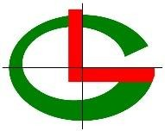
*Reference Link | http://gunung.webcrowdsolutions.com
Remarks (If any)

* Nature of Business with Products/Services Names
We Manufacture | GREENBEAN COFFEE ARABICA AND ROBUSTA, ROASTED BEAN COFFEE ARABICA AND ROBUSTA
We Export | GREENBEAN COFFEE ARABICA AND ROBUSTA,  ROASTED BEAN COFFEE ARABICA AND ROBUSTA
We Import
We Supply | GREENBEAN COFFEE ARABICA & ROBUSTA ROASTED BEAN COFFEE ARABICA & ROBUSTA
We provide services for | FORWARDER SERVICE EXPORT & IMPORT
Website Information
USP of your Products/ Service (Any feature on what you claim that your products are best.)
Keywords
About Office
*Establishment Year | In 6 September 2016
*Name of Owner/CEO | MIFTAHUDIN SHAF,SH
Experience | Exported Greenbean Coffee to various countries including the United States, Saudi Arabia, Korea,  Egypt, Lebanon, and other countries.
Qualification or Specialization | Greenbean Coffee Arabica & Robusta
Number of Employees | 40 WORKER
Turnover | Rp. 17.000.000.000 / $1.133.333 USD annually.
Quality Certification | YES, We have Certification of Halal, fda and organic
Achievement and Awards | We have participated in several coffee exhibitions in several countries such as Dubai, and America.
*About US (A brief introduction of your company) | Koperasi Produsen Gunung Luhur Berkah is a cooperative-based business entity with business activities engaged in the production of agricultural  and plantation commodities. for coffee commodities we have a total coffee land area of 1200 Hectares.

*About Factory or Manufacturing Unit (only for manufacturers)
Area
Machinery | We have machine to support our coffee processing including : Sorter Machine, Sifting Machine, Suton Machine, Huller  Machine, Roasting Machine.
Production Capacity | Greenbean Coffee Arabica = 400 Ton Annually  Greenbean Coffee Robusta = 1000 Ton Annually
Raw Material Used | Greenbean Coffee Robusta & Arabica, Raw Of Coffee (Cherry)
Customized Production Facility
Testing Facilities
R&D Facilities
How many Factories you have? | We Have One Factories For Coffee, And 4(Four) The Rice  Warehouse
USP of your working
About Operations
*Countries you deal in | Egypt, Saudi Arabika, Lebanon, United States.
*Industries where you want to sell your products/Services | Industry And Retail Market
Clientele (Mention names of your clients) | Egypt (A To Z Company & Alpostan Company), Saudi Arabia (Alshahl Alakhdar), Lebanon (Arc Build)
Packaging Material | Sack Jute @60kg
Customized Packaging Facility
CAD (Computer-Aided Design)/CAM (Computer-Aided Manufacturing) Facility
Any Other Information | not only the production of greenbean coffee, our company also produces roasted coffee processing and ground coffee.We already have a brand with  the name Hofland Coffee.
*Minimum order Quantity | 200 KG FOR GREENBEAN AND ROASTED BEAN COFFEE ARABICA & ROBUSTA
*Price of your products | GREENBEAN :  ARABICA  1. ARABICA NATURAL = 10 USD/KG

- ARABICA FULLWASHED = 9 USD/KG
- ARABICA SEMIWASHED = 8,5USD/KG
- ARABICA HONEY = 8,5USD/KG ROBUSTA
- ROBUSTA GRADE 1 = 5,5 USD/KG
- ROBUSTA GRADE 2 = 4, 7USD/KG
- ROBUSTA GRADE 3 = 4,4 USD/KG ROASTED BEAN:
- ARABICA = 15,1 USD/KG
- ROBUSTA = 10,5USD /KG
*Customization on products if required by your clients .Yes/No | YES
NOTE:- Products Name & Products Images mages quality –High

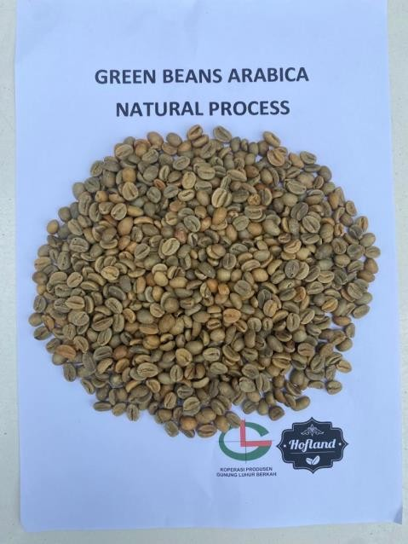 | 