**Tactile walls**

Most tactile objects are best placed as low as possible

on the wall. There are several possibilities: you can use

loose panels or fix the tactile objects on the wall itself.

Loose panels have the advantage that they are easily

replaced so you can vary infinitely. This variation can

be expanded by using Velcro strips. There is a kind of

cloth to which Velcro strips stick. By covering the

wooden panel with this cloth you get a multi-purpose

background on which you can fix anything equipped

with a strip of velcro. This way a visitor can take anything

he likes off the panel and play with it or take it to his

own little comer. Because the objects are so easily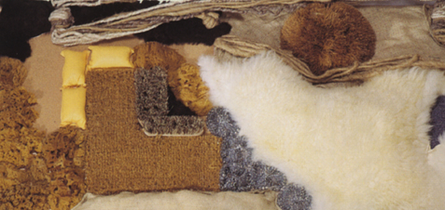

interchangeable the range of variations in structure

and contrast is virtually infinite. The objects are also

easily cleaned because they can be taken off and

machine washed. But do no forget to put a cover strip

on the Velcro before washing it or bits of fluff and hair

will stick to it and render it useless. As far as the choice

of tactile materials is concerned you are also dependent

on the requirements of the ‘outside world’. Fire safety

is essential in a Snoezelen-facility and the requirements

limit your choice of materials. Maintenance and hygiene

are also decisive factors.

After all, touching is something we do with our

entire body and this means that the equipment will

not always stay clean. In fact it may become a source of

infection and a breeding place of bacteria if maintenance

is insufficient. Many natural materials do not burn, but

singe only. Animal skins, wool, sponges and other natural fibres do not burn easily and are easy to clean. 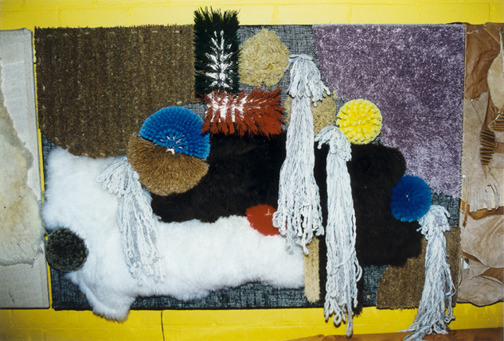There are also synthetics that meet the requirements, both

fabrics and more voluminous materials. What's more,

many fabrics can be treated with fire retardant chemicals.

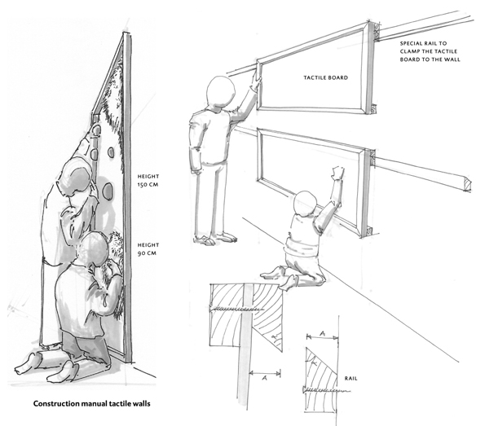But then these fabrics are harder to clean. Starting from

the assumption that essentially any material can be

used for our purposes, unless it is sharp, fragile or

toxic, the possibilities are many. Your creativeness and

being open to the experiences and the reactions of

the visitor of a Snoezelen-room decide your creation.

It should be avoided that design becomes more

important than tactile value. On the other hand a

design that calls up strong visual stimuli can be very

inviting. A balance between design and tactile value

will provide maximum effectiveness of a tactile wall.

**Tactile boards**

Tactile boards may have various sizes, depending on

the way they are to be used. For tactile material we can

choose all kinds of synthetics, natural products and

things like brushes, mops, etc., provided these are

neither sharp, nor toxic or inflammable. Small boards

(e.g. 50 x 70cm) can be used on a table or a wheelchair.

It is practical if they can be fixed with small clamps.

Larger boards can be laid on the floor or fixed on the

wall. For the basis of a tactile board 18mm plywood or

chipboard is most suited. The material can be fixed on

it either with (a) a staple-gun, or (b) Velcro strips.

With a staple-gun materials can be fixed on the

board very easily. Take care that the staples are properly

fixed, if necessary you can hammer them in a little

more. Beforehand the board is covered with thin fabric

or carpet or painted with wall paint. When fixing the

materials on it try to conceal the staples as much as

possible so they are not felt.

Gluing the material on the board is also recommended, provided non-toxic

glue is used. Between soft material like wool, carpet

rope, etc., we put some hard things for the sake of

contrast. Suited are coconut matting, stiff brushes,

wood, nylon cord, strips of formica, synthetic sponges.

All sorts of brushes, brooms and mops give a very

special effect.

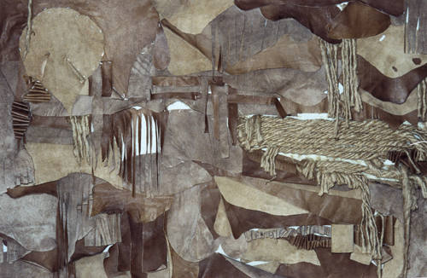

We can make a flat object but we can also work in

relief, or even a combination of the two. The arrangement

of the material depends on your choices and taste.

The aesthetic element WI often prevail. But always

remember that you are making a tactile board and not

a work of art (b) Using Velcro has the advantage that

the material is easily replaced and any combination is

possible. Velcro also has the advantage that the material

can be easily removed for cleaning. Another important

plus-point is that the visitor can remove things from

the board and take them to his private little nook

The board is covered with fabric on which Velcro

sticks well. There is special cloth for this purpose on

the market. The Velcro strips are attached to the

material with a sewing machine or with glue. Velcro

clings very well so everything should be tightly fixed.

The cloth is stretched on the board with a staple-gun.

Here too, it is important that the staples are properly

fixed, so hammer them in if necessary.