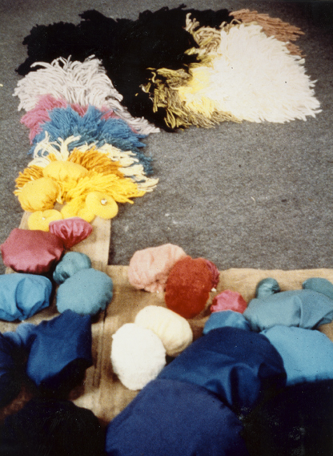**Tactile blanket**

*Assembly*

**>** Different tactile materials are loosely attached to

a blanket (made of Jute), buttoned, sewn or fastened

with knots;

**>** Following elements are used:

> Knots and sausages made of fabric/filled with

different materials

> Yarn bunches/long and short strings

> Scourers

> Bells

**>** The fabric strips are pulled over round wooden

rods and attached to a wooden frame (sliding in);

(the wooden frame should measure approx.

60 by 60 or 80 by 80cm)

*Purpose*

**>** The fabric curtain should be safely secured to

the ceiling

**>** For tactile, visual and basal stimulation

(stimulation of the entire body)

