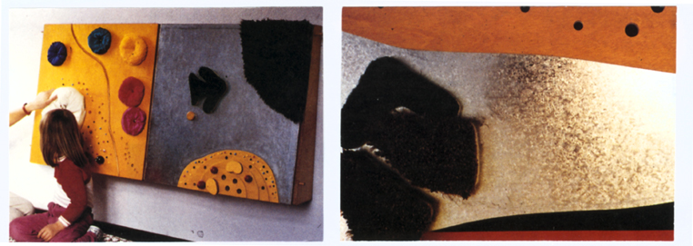
Tactile activity board with added elements
The activity boards are designed in such a way as to
offer disabled people a variety of ways to discover and
experiment. The individual boards filled with different
materials (metal/wood/Velcro/fur etc.) encourages
exploration the textures and characteristics (surface/
hardness/temperature/colour). People with disabilities
get an understanding through play and exploration of
the boards and using the additional elements.

Apart from developing the fine motor skills, basic
exercises with arms, legs and the whole body are being
carried out by the people playing with and exploring the
boards (arm stretch/rotation/body stretch/hip stretch).
Some disabled people might even feel encouraged to
stand up independently in front of the boards without
being asked; motivation and enjoying the activities
seem to let people almost forget about the effort
required to play while standing up (without supporting
aids/with help of a therapist). The activity boards are
designed with different levels of difficulties.
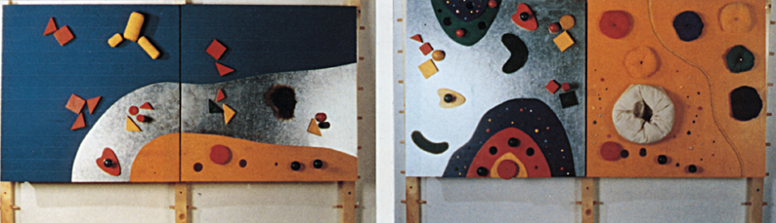
The tactile peg-board where textile elements have to be collected,
offers an easy task. It doesn’t require a lot of effort and
hand activity and the reward can easily be seen when
the pieces are being collected (additional: clear jerking
when pulling).
Pulling/Collecting five pieces of fabric doesn’t take
long (in case of a short attention span of the disabled
person).
Velcro-magnet-peg-boards demand a bit more
attention and ability of disabled people as well as
creativity and activity Motion sequences and activities
require a more detailed planning.

