Soft rattles
Assembly
> Little bells are attached (sewn, plaited, fastened
with knots) to textile elements (cushions, mops,
braids made of wool or fabric).
Purpose
> For audible stimulation and
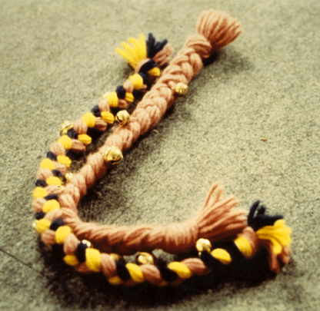
> To stimulate physical activity

