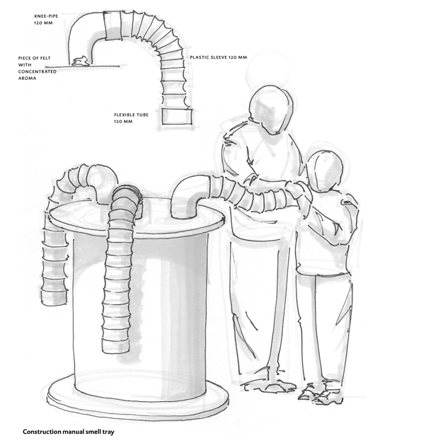**Smell trays**

Smells can also be presented separately. We have had

particularly good experiences with so-called smell

trays. On a rotating base a number of pvc knee-pipes

have been mounted (5in diameter) with pieces of

flexible tube stuck in them. When not in use, these

tubes hang down. Because most aromas are lighter

than air they do not spread them. As soon as we pick

up the hose and put it under our nose the smell is

released. This way the aroma will last long and is only

used when we lift the trunk. When we paint the device

in attractive colours and mount it on a rotating base it

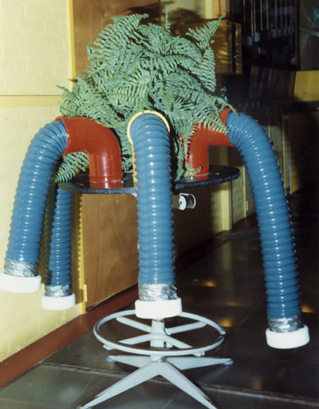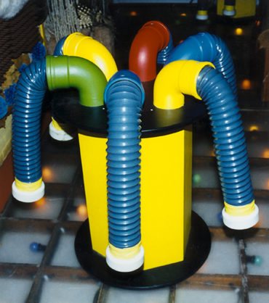will look very inviting.