**Rigging rope**

Rigging rope

approx. 48 mm Twist rigging rope

in opposite direction

and staple wool

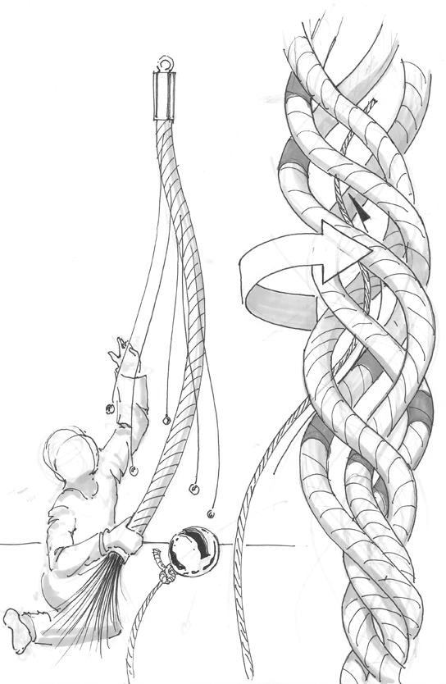threads in-between

Copper

bells

**Construction manual rigging rope tactile mobile**