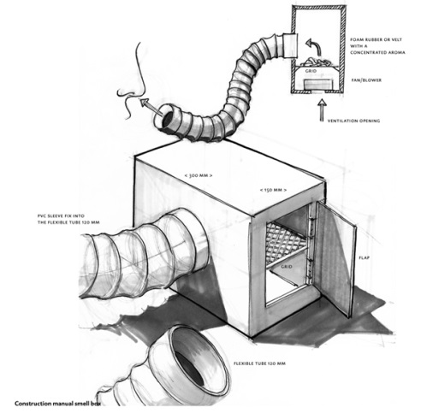
Hot and cold air as a tactile sensation
The use of current of air as tactile sensations is
quite another form of perception. Everybody knows
how lovely it is to walk on a windy beach, your hair
blowing in your face and the salt on your lips. Or when
it is hot to put your head out of the window of a car to
cool. The current of air caresses our face, as it were.
We can call up these sensations artificially by using
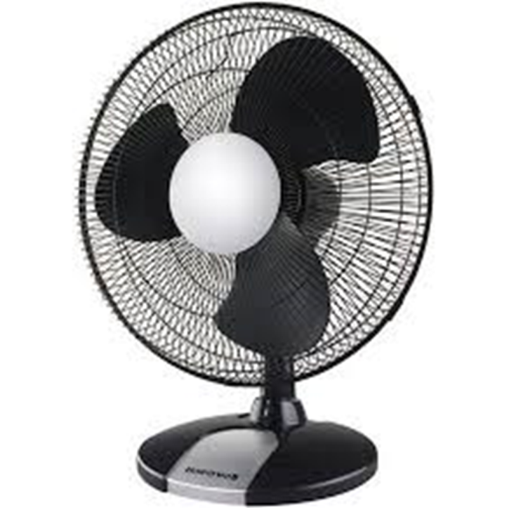
fans, possibly combined with a convector heater.
With flexible tubes (like those used for sanitary facilities)
we can direct the currents of air. The resident can play
with these tubes and decide for himself where he
wants them to blow. He can let them blow in his face
or through his hair or make things move, like curtains
or plastic strips.
The practical realization depends on the available
space and means. A simple wooden box with a long
flexible tube on one end offers a range of possibilities.
In this box we can place a convector. Remember the air
holes, though! Instead of equipping the opening with a
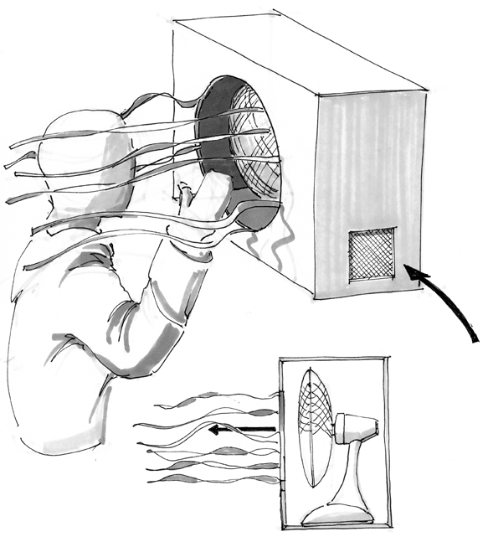
tube you could attach rags of wool and plastic strips to
it. As soon as we start the fan the rags begin to move
to the current. The visitor can feel the rags with his
face and hands and at the same time feel the warm or cold current of air.

