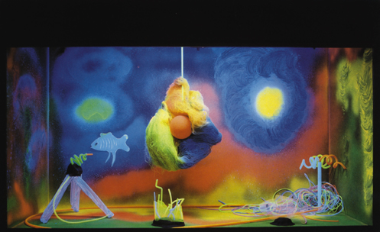

Black light-Aquarium
This is a restful focus in a multi sensory room, providing
a gripping spectacle, which continues to fascinate
because of the beautiful colours and the rotating
objects. these boxes can also be supplied in different
sizes and with other themes. The black light aquarium
is portable.
This wooden box has a top that can be pulled off
so that , if desired, changes can be made inside the box.
At the top of the box there is a small rotating motor to
which one can attach hanging objects.

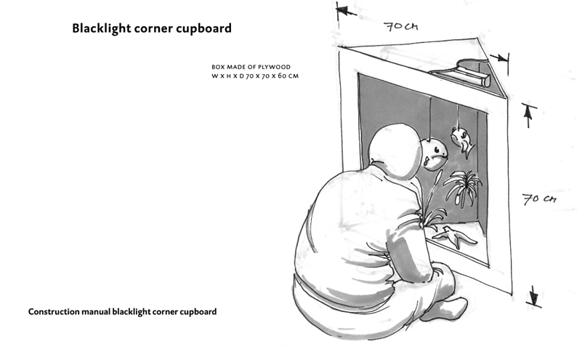

Blacklight corner cupboard
The blacklight corner cupboard is portable and constructed
similarly to the blacklight aquarium.
Construction manual blacklight aquarium
Construction manual blacklight corner cupboard

