A sound rack
Mounting a variety of musical instruments on a rack
or a wall gives a range of possibilities. Instruments like
triangles, drums, woodblocks, maracas, cymbals and
tambourines produce a great diversity of sounds.
The simplest solution is to suspend the instruments by
a cord so the visitor can easily reach them. Alternatives
are cowbells, Indian bells, gongs, etc.
Bamboo rods and hardwood blocks produce yet other sounds.
Thin metal bars, pieces of brass tube or thin-walled
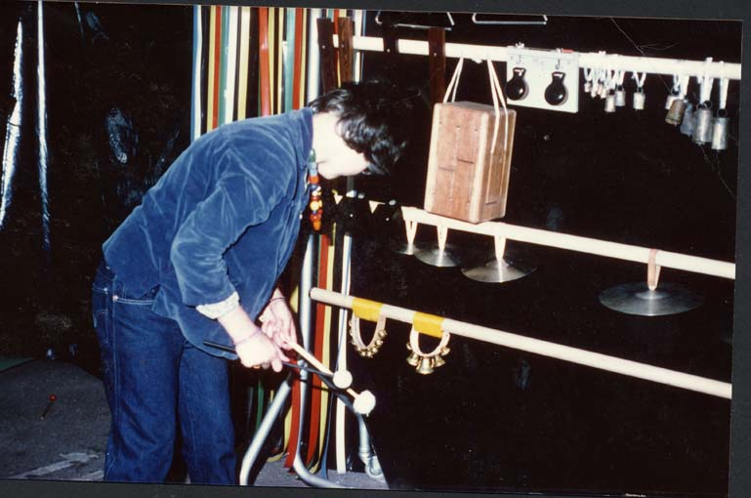
iron tubes produce a special, shrill sound.

