Swedish handmade Acoustic Guitars
Wälivaara OM Steel string
OM stands for “orchestra model” and was originally a larger sized guitar for strong projection on stage to measure up with the contemporary louder brass ensembles. Since the introduction of the large Dreadnaught model, the OM is nowadays of less stature and considered as the finger pickers top choice. The OM model has grown tremendously in popularity during the last years due to its articulate yet powerful voice, its attractive size and comfortable playing,
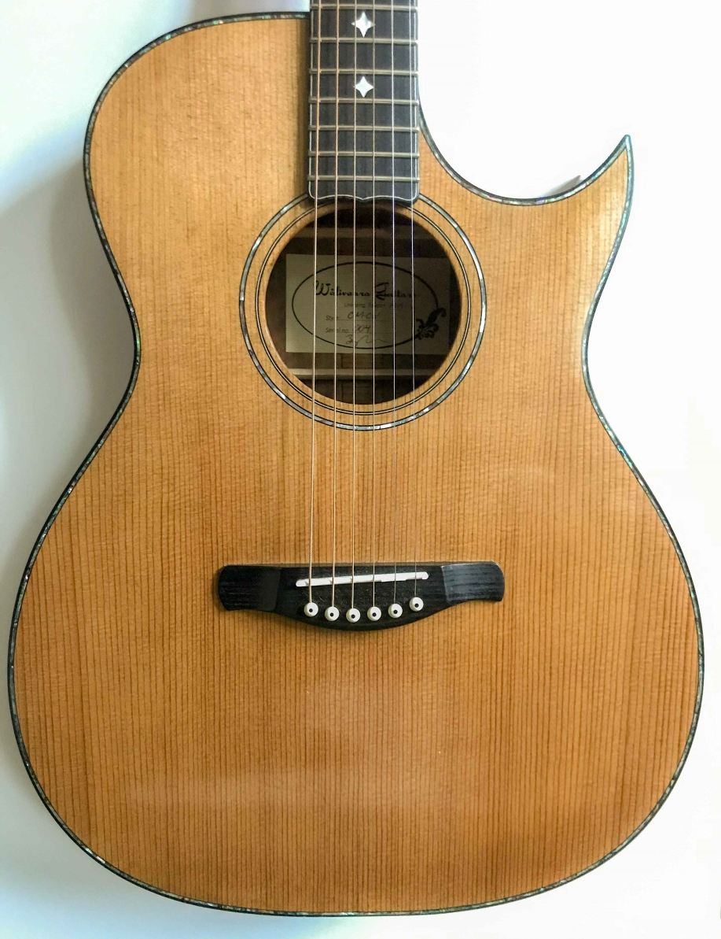
OM Steel string with optional cutaway, shellac coating, abalone body trimming and star inlays on fretboard with purfling

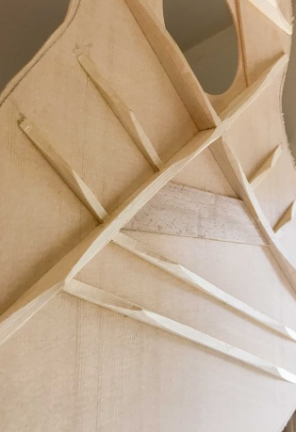
X-type bracing pattern (spruce)
Optional Floretine cutaway with ablone trimming around body rim
Bolt joint "double tenon" superior acoustic coupling, and ensure that fretboard stays straight

Standard configuration
Type/model: OM Steel String
Neck: 25.34” (645 mm)
Nut width: 44 mm
Total Length: 1020 mm
Upper bout: 297mm
Lower Bout: 381 mm
Body length: 492 mm
Body depth: 102 mm (bottom), 84 mm (top)
Top: Sitka spruce grade AA
Bracing: X shape
Back+Sides: Mahogny Sapele
Rosette: Abalone + b/w/b purfling
Bridge: Ebony
Headplate: Ebony + Mother of pearl logotype
Binding: Ebony + b/w/b purfling
End graft: Ebony + b/w/b purfling
Neck: American mahogany, double action truss rod
Fretboard: Ebony + MoP fret markers, side dots
Headstock: Solid headstock with MoP Logo inlay
Tuners: 15:1 GS chrome finish
Body finish: High gloss finish
Neck finish: High gloss finish
Price: 21 000 SEK

