- Task 1:
Open play store and write word “Ecommerce” in the search bar.
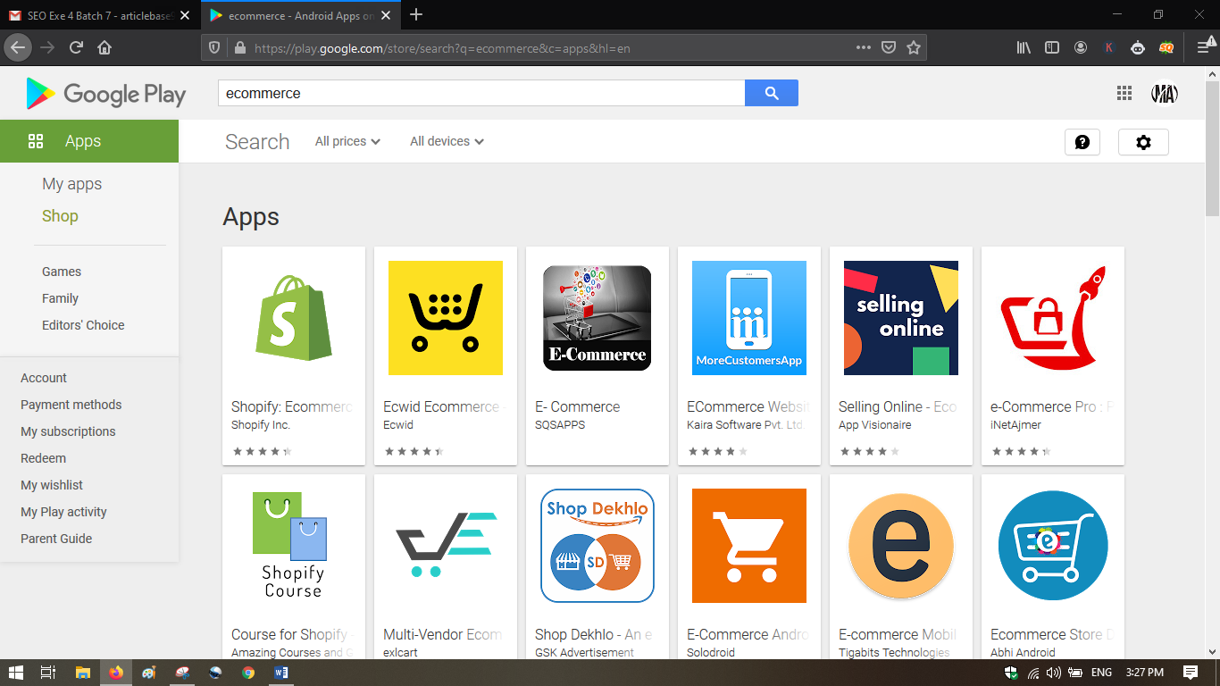

Select top 3 apps from the search list.
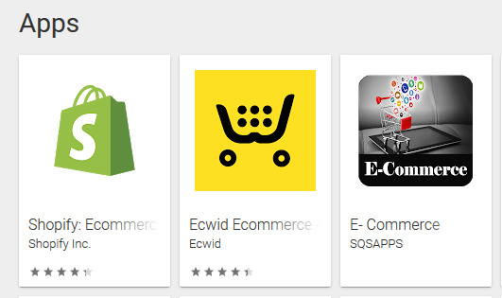
- App 1:

Shopify: Ecommerce Business


Run your business wherever you are. Whether you have one or multiple Shopify stores, this app makes it easy for you to manage your orders and products, connect with staff, and track sales.
PROCESS ORDERS
• Fulfill, refund, or archive orders for each of your store locations
• Print packing slips and shipping labels
• Manage tags and notes
• Add Timeline comments
• Track conversion right from your order details
• Create new draft orders and send them to your customers
• View fraud analysis
MANAGE PRODUCTS AND COLLECTIONS
• Add products manually or through barcode scan
• Edit item characteristics or variants
• Create and update automated or manual collections
• Manage tags and categories
• Define product visibility on sales channels
• Sync with 3rd party sites to sell on Etsy, Amazon, Ebay, and more
RUN MARKETING CAMPAIGNS
• Grow sales with a Google Smart Shopping campaign
• Create Facebook ads on the go
• Track results and get custom recommendations to improve your results over time
• Write new content for your blog
FOLLOW UP WITH CUSTOMERS
• Add and edit customer details
• Contact customers
CREATE DISCOUNTS
• Create special discounts for holidays and sales
• Monitor discount code usage
REVIEW STORE PERFORMANCE
• View sales reports by day, week, or month
• Compare sales across your online store and other sales channels with a live dashboard
SELL ON MORE SALES CHANNELS
• Sell online, in-store and more
• Reach your customers on Instagram, Facebook and Messenger
• Sync inventory and orders across each channel
EXTEND YOUR STORE'S FEATURES WITH APPS AND THEMES
• Access your Shopify apps from orders, products, and customers, or right from the Store tab
• Browse our catalog of free themes and change your online store appearance
Shopify handles everything from marketing to payments, including mobile payments, a secure shopping cart, and shipping. Whether you want to sell clothes, jewelry, or furniture, Shopify has everything you need to run your ecommerce store.

- App 2:

Ecwid Ecommerce - Sell Online with Store Builde



Join the 1.6M small businesses that have trusted the Ecwid E-commerce platform to sell online.
The Ecwid app has everything you need to sell online from anywhere in the world. This online store builder lets you create, promote, and manage your online small business on-the-go from your mobile device.
With Ecwid, managing your online small business is quick and efficient. Easily add new products by snapping a pic, share it across Facebook and Instagram, and accept payments directly in the app. Then receive push notifications when orders are placed so you never miss a beat.
And we make starting your online stores fast and easy. From setting up your retail small business to making sales and growing your brand, we’ll be with you every step of the way.
Download the app to launch your business and start earning today!
SELL ONLINE ANYWHERE
Set up your Ecwid store once to easily sync and sell across websites, Facebook, Instagram, social media, marketplaces like Amazon and Etsy, and live in-person. We give you the flexibility to choose the retail e-commerce platform that’s right for you. Get started with one or try them all!
ADD PRODUCTS AND MANAGE INVENTORY
Ecwid’s online store builder makes setting up your retail ecommerce business fast and easy. Spend less time building your online store and more time selling to grow your small business quickly. 😎
Upload new products easily by snapping a picture, view and manage your inventory, edit product options, update pricing, and change product details such as weight and availability with just a few taps. The easiest selling app for small business commerce.
PROMOTE EVERYWHERE
Build brand awareness by promoting your business across Facebook and Instagram anytime, anywhere.
BOOST SALES
Offer promotions, coupons, and discounts to attract new customers and boost sales.
WORDPRESS PLUGIN
Ecwid seamlessly integrates via a plugin to your current WordPress site — your design is preserved and no programming is needed. Add your store to as many additional sites as you want and manage it from one place. Any changes you make are mirrored instantly across all your sites. Easily import products from your WooCommerce store.
PROCESS ORDERS
Receive push notifications 🔔 when an order has been placed and process orders on-the-go from your mobile device. For a more convenient selling experience, you can also contact customers right from the app to offer order updates or ask for additional information.
ACCEPT PAYMENTS
Choose from Square, Stripe, Chase, PayPal, and more than 50 other payment options to accept credit and debit card 💳 payments quickly and securely.
SMART SHIPPING
Help your customers choose the right shipping method with real-time shipping rates that let them see costs based on their location.
SELL AROUND THE WORLD
Let your clients enjoy shopping in their preferred language. With 50+ languages available for your storefront, you can provide the same consistent shopping experience and sell to customers from all over the world from a single store.
PLANS & FEATURES
Try out the app FREE for 14 days. After 14 days, you can continue managing your store for free from a web browser, or upgrade to one of 3 paid plans for access to the Ecwid app and other cool features.
Venture plan
– up to 100 products
– up to 100 MB per download
– live chat support
– Facebook shop, discount coupons, bulk discounts, and more
Business plan
– up to 2500 products
– up to 1 GB per digital download
– live chat and phone support
– marketplace integrations, staff accounts, wholesale prices, advanced product options, and more
Unlimited plan
– unlimited products
– up to 10 GB per download
– priority support
– all available basic and premium features
QUESTIONS?
We’d love to hear from you. Shoot us a note at mobile@ecwid.com
- App 3:

E- Commerce


Electronic Commerce is a educational apps for students, Computer science and BBA program students also take reading advantage from this app.
Main Topics of E- Commerce
Introduction to Electronic Commerce
The Development and Growth of Electronic Commerce
Business Models, Revenue Models, and Business Processes
Advantages of E-commerce
Economic Forces and Electronic Commerce
Network Economic Structures
Identifying Electronic Commerce Opportunities
SWOT Analysis
International Nature of Electronic Commerce
Summary
E-Commerce Payment Systems
E-Commerce Transaction
Terms are related E-commerce.
e commerce
commerce website
e commerce website
e commerce websites
ecommerce platforms
ecommerce website design
e commerce business
best ecommerce platform
best ecommerce sites
ecommerce solutions
e commerce sites
ecommerce web design
ecommerce shop
electronic commerce
ecommerce development
top ecommerce websites
e commerce need of today's business world
internet e commerce
online ecommerce website
top ecommerce sites
ecommerce development company
simple ecommerce website
e commerce online
ecommerce design
web e commerce
ecommerce web development
what is e commerce
online ecommerce store
ecommerce platforms comparison
most popular ecommerce platforms
Download this app and start learning with us :)

Now brainstorm one (1) related keyword or search term for each app (Like sports products,
Garments products, electronics products but relevant to the selected apps).
Then sign into Google Trends (https://trends.google.com/).
Fill the input field with the one of the keywords or search terms of the selected apps.
Now click on compare, add the second keyword and do the same process for the 3rd keyword.
Take screenshot showing “Interests by Graph” in the word file
- From app 1
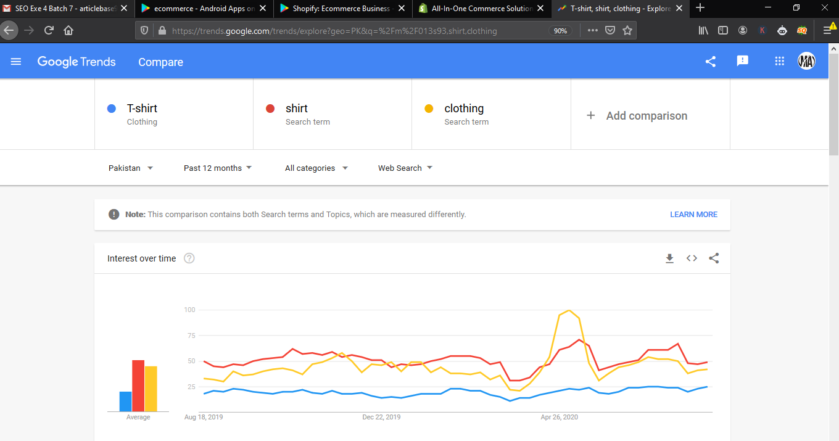
- From app 2
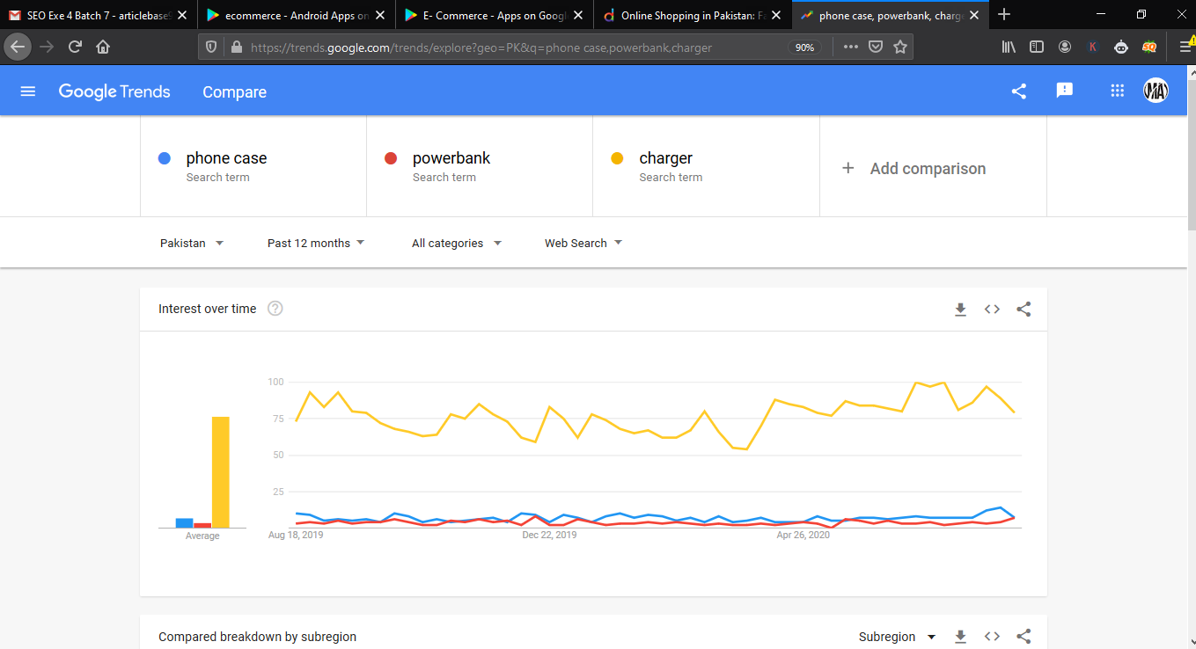
- From app 3

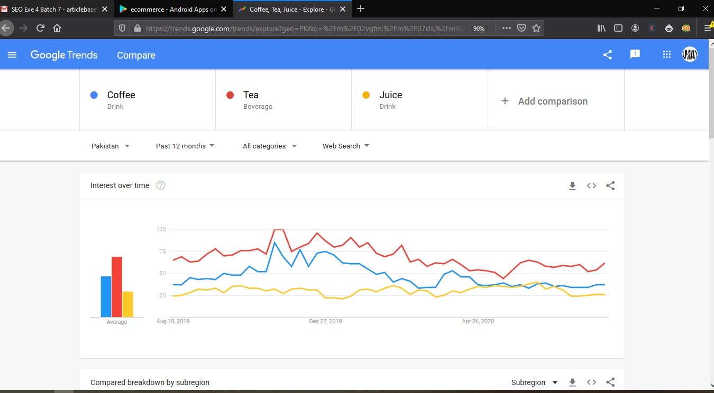

Also mention the highest trending keyword or search term in the word file.
- FROM APP 1: CLOTHING
- FROM APP 2: CHARGER
- FROM APP 3: TEA

- TASK 2
Use the same selected keywords to perform this task (3 marks)
I. Open YouTube (http://youtube.com).
II. Write each selected keyword or search term one by one in the YouTube search bar.
III. Open any video from the search results.
IV. Copy the video title and description of each video in the word file along with the screen shoot.
V. Submit the exercise.

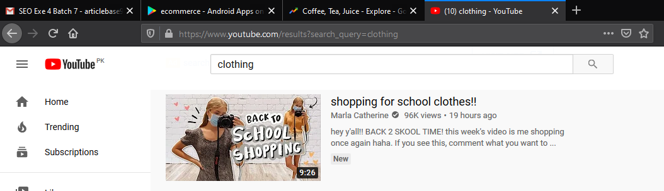

Clothing

Shopping for school clothes!!

hey y'all!! BACK 2 SKOOL TIME! this week's video is me shopping once again haha. If you see this, comment what you want to wear the first day of school! I'm thinking a paper bag with crocs
**stay tuned for a back to school clothing haul!!**
☆ follow me on instagram for more outfit inspiration - http://www.instagram.com/marlacatherine
☆ merch - http://www.shopmarlacatherine.com
☆ my vlog channel if you want some *chaotic* energy - https://youtu.be/RcSqQV21QK8
☆ my mom's channel (if you want to see the crazy adventures of my entire family) -https://www.youtube.com/user/TheCurvy...
☆ spotify (lots of cool tunes for every month of the year) - marlacatherine
☆ depop (always selling my clothing on there) - marlacatherine
☆ help me translate this video into another language! https://www.youtube.com/timedtext_cs_...
✭ P.O. BOX (if you want to send me something) Marla Catherine PO Box 1432 Spanish fork, Utah 84660
☆ music ☆ https://kilamdapro1.bandcamp.com

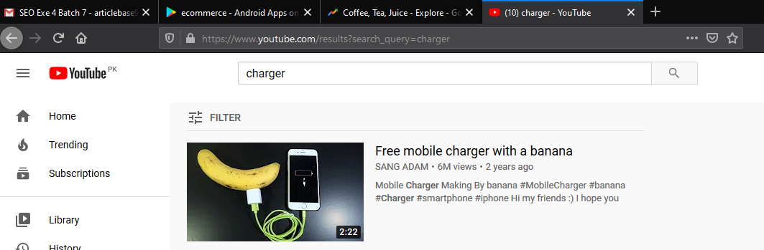

Charger

Free mobile charger with a banana
Mobile Charger Making By banana
#MobileCharger #banana #Charger #smartphone #iphone

Hi my friends :) I hope you enjoy this tutorial and see you in the next ideas videos!

Thanks For Watching, i hope you like this video. Share, Support, Subscribe.!!! Subscribe to : https://goo.gl/wMfCPU

= Corona iphone XR/XSMAX/XS/X/8/7/ CASE from New 2020 https://teespring.com/corona-iphone-x...

- Music : Cartoon - On & On (feat. Daniel Levi) [NCS Release] link https://www.youtube.com/watch?v=K4DyB...

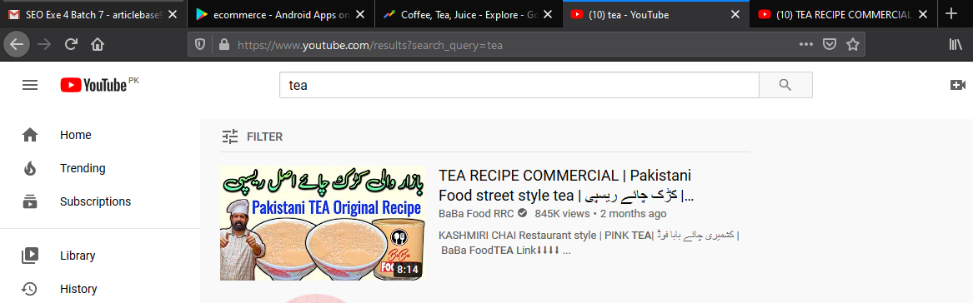

Tea

TEA RECIPE COMMERCIAL | Pakistani Food street style tea | کڑک چائے ریسپی | BaBa Food RRC Chef Rizwan
KASHMIRI CHAI Restaurant style | PINK TEA | کشمیری چائے بابا فوڈ | BaBa Food TEA Link⬇⬇⬇⬇ https://youtu.be/Z3MqbXM1xeU
TANDOORI CHAI Recipe | Extremely Hot Pot Tea | pakistani Indian Street Food | पुने की फेमस तंदूरी चा Link⬇⬇⬇⬇ https://youtu.be/7tnl1G_7_wY
Garam Masala Recipe - How to make commercial Garam Masala in urdu hindi - गरम मसाला BaBa Food Link⬇⬇⬇⬇⬇ https://youtu.be/NY4zfS8t5z8
Start your own business - Food ka business (apna karobar mission) BaBa Food / BaBa Fun RRC Link⬇⬇⬇ https://youtu.be/dVekOZ9C1m4
Mayonnaise recipe/ Commercial Mayonnaise/ Restaurant style/easy recipe/ Chef Rizwan/ Baba Food RRC Link⬇⬇⬇⬇ https://youtu.be/oEADmKNy51w
Quick Eggless Mayonnaise commercial Recipe at Home How to make Eggless Mayo - Veg Mayonnaise Recipe Link⬇⬇⬇⬇ https://youtu.be/UI3pQPR7jaU

*السلام علیکم* یہ ہمارا نیو چینل (بابافن آرآرسی) *BaBa Fun RRC®* ہے۔ اس چینل پر ہم آپکو *فوڈ سے متعلق کاروبار ، فوڈ سیفٹی ، کھانوں کو دیر پا محفوظ رکھنے*۔ اور فوڈ کے متعلق آپ کے تمام سوالات کا جواب مہیا کریں گے۔ تازہ ترین اپ ڈیٹ کے لئے چینل سبسکرائب کر لیں۔ شُکریہ
*چینل لنک*👇👇👇
https://www.youtube.com/channel/UCRYQ...
Assalam- o-Alikium this is Chef Ramish Rizwan ch from Baba Food RRC We hope everyone is fine by the Grace of Allah Almighty ==================== Totally Free: Golden opportunity for unemployed people.and Ladies Learn how to make a kind of meal in the restaurant. And start your own business? Visit our Facebook Page (Baba Food RRC) and subcecribe Our YouTube channel (Baba Food RRC) for every type of restaurant style and home made recipes.
DISCLAIMER: This Channel DoES NOT Promote or encourage Any illegal activities, all contents provided by This Channel is meant- for EDUCATIONAL PURPOSE only. Copyright Disclaimer Under Section 107 of the Copyright Act 1976, allowance is made for "fair use" for purposes such as criticism, comment, news reporting, teaching, scholarship, and research. Fair use is a use permitted by copyright statute that might otherwise be infringing, Non-proft, educational or personal use tips the balance in favor of fair use.
===============================================
For more interested videos or recipes subscribe our youtube channel and press bell icon ===============================================
Facebook page link Baba Food RRC: https://www.youtube.com/channel/UCnGe...
Persnol Facebook id Chef Ramish ch: https://www.facebook.com/Baba-Food-RR... Facebook: https://www.facebook.com/profile.php?...
Instagram Baba Food RRC official : https://instagram.com/babafoodrrc?igs...
Persnol Facebook id Chef Rizwan ch: https://www.facebook.com/rizwanch.chef
Thanks for watching

