Hands-on Exercise No. 1
Batch-07
Digital Marketing

1. Create a Facebook business Page and upload a profile picture as well as cover photo

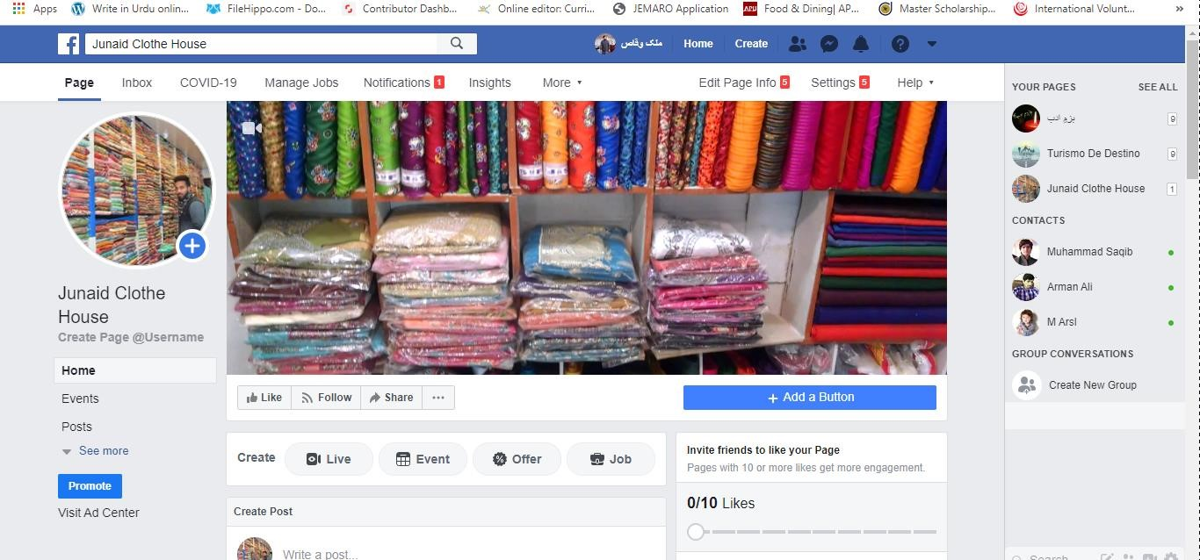

Setup a Facebook Shop
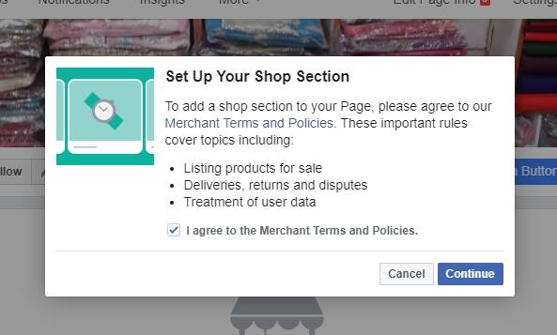



- Briefly describe your business.
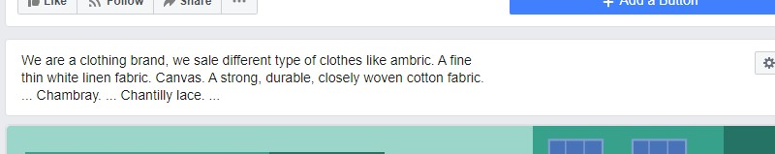

- Add at least two products in the shop
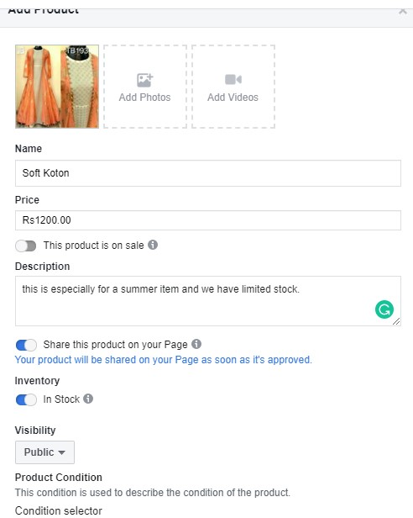
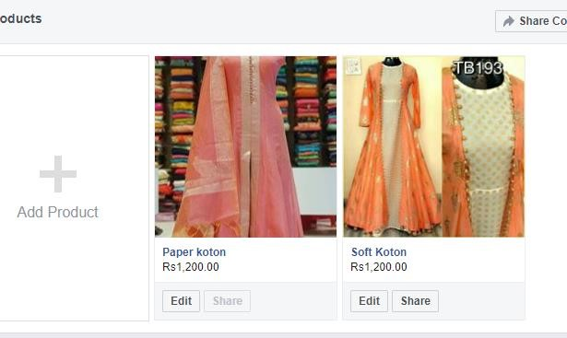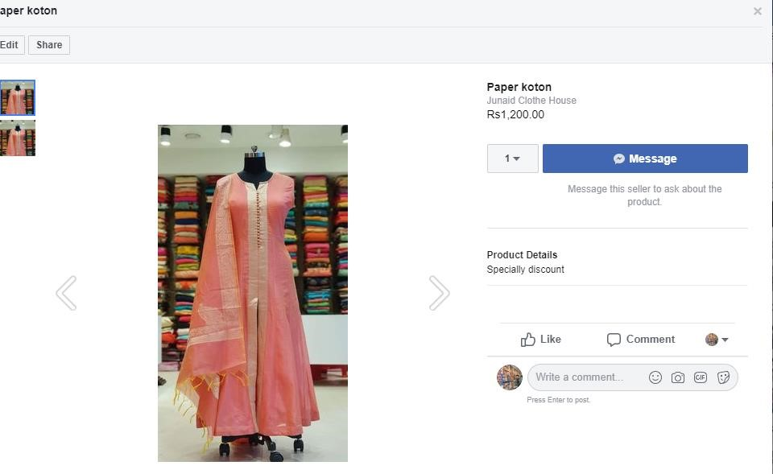

- Add a call to action button “Shop Now” on the business page
