**Chairman’s Report**

At the last AGM we were excited to see the shiny hull of Trio 500.   Since then we have had the dinghy show where Trio 500 was displayed and it’s sale will hopefully just be the start of the Trio class expanding again.   I am looking forward to hearing from Andy if anything is happening with the Versa and Zero classes.

This year I have to thank all the clubs that put on events that we are invited to.  In particular Cotswold, Exe, Shustoke, Hawley, Paignton, Sutton Bingham, Cransley and any others I have forgotten.   We should also thank Noble Marine for sponsoring our events. It was sad to hear that Kingsmead S.C. that had put on many good events in the past,  including 30th May 2015 were just given a few months’ notice to clear their water and the club has been disbursed. Still on the Kingsmead website:

**Sail training for adults in stable dinghies!**

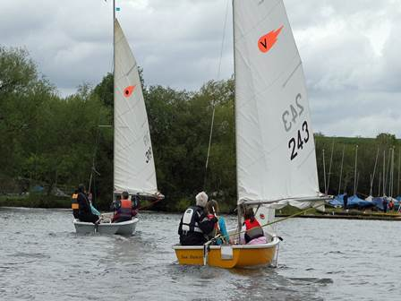

I would like to thanks the committee.  Bill Gott no longer has his Trio and has tendered his resignation as Treasurer.  Bill has done sterling work keeping our books in order,  issuing cheques as required and giving us easy to understand reports over many years.  Thanks to Steve Ashford for keeping the smart new website up to date and creating the facebook page,  which I hope will add an extra dimension to the association.   Enormous thanks go to Bob Horlock.  I am so glad he has recently retired and has given so much time to the class association.  He has revamped the membership database, did a lot of organising for the dinghy show,  and was then there for all days of the show.  I hope that all the energy he is putting into the class will mean that there are more people participating and enjoying class events.

David